**Franchies Management CRM Using Salesforce Technology**

**Phase 1: Problem Understanding & Industry Analysis**

**Goal**: Understand what we’re building and why.

**1. Requirement Gathering**

Talk to stakeholders (franchise owner, outlet managers, sales agents, quality auditors).  
Example requirements:

* Track all outlet**s** with details (location, manager, license validity).
* Record sales transactions per outlet.
* Conduct quality compliance audits with scores/checklists.
* Generate performance dashboards (e.g., top outlets, sales vs target).
* Set up alerts (e.g., license expiry, compliance overdue).

**2. Stakeholder Analysis**

* Admin (You**)** → sets up system, manages users/objects.
* Franchise Owner (Head Office Manager**)** → monitors sales & compliance across all outlets.
* Outlet Manager → manages sales entries and local compliance records.
* Quality Auditor → performs compliance checks, enters audit results.
* Customer Service (optional**)** → logs customer complaints against outlets.

**3. Business Process Mapping**

**Flow Example:**  
Outlet registers → System creates Outlet record →  
Sales transactions logged daily →  
Monthly compliance audit scheduled →  
Compliance issues flagged →  
Reports & dashboards update →  
Franchise Owner reviews → Action taken.

**4. Industry-Specific Use Case Analysis**

In the franchise industry (restaurants, retail, food chains):

* Outlets must maintain consistent quality to protect brand reputation.
* Sales vary across outlets → need for performance comparison.
* License validity and compliance audits are critical to ensure legal & brand standards.
* Automated reminders and dashboards are important for proactive management.

**5. AppExchange Exploration**

* Search for apps like “Franchise Managemen**t**” or “Outlet Management” on AppExchange.
* Some solutions exist (e.g., retail/store management apps), but we’ll build a simplercustom solution in Salesforce to learn object modeling, flows, and dashboards.

**Phase 2: Org Setup & Configuration**

**1: Salesforce Edition**

* Go to developer.salesforce.com.
* Sign up for a Free Developer Org (you’ll receive login via email).
* Log in and confirm the Lightning Experience is enabled.
* 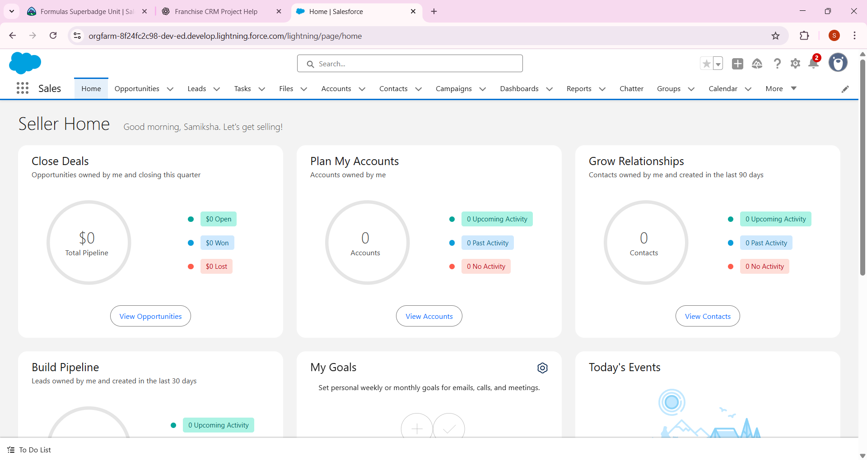

## **2: Company Profile Setup**

* Click **⚙️ Setup (gear icon)** → **Company Information**.
* Edit:
  + Company Name: Franchise Management CRM Pvt Ltd
  + Local Time Zone: Asia/Kolkata (IST)
  + Currency: INR (or USD).
* Save changes.

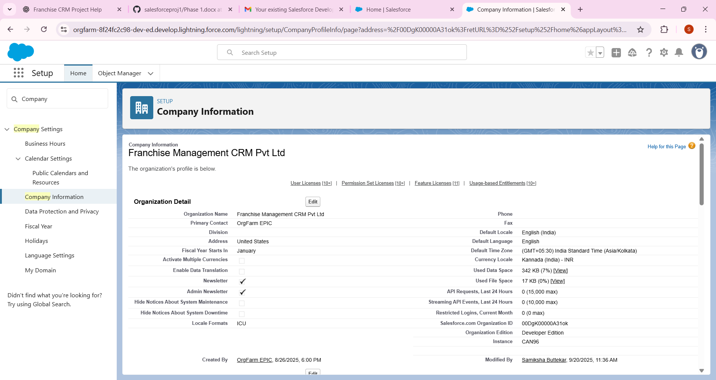

## **Step 3: Business Hours & Holidays**

* In Setupp → Search **Business Hours.**
* Create new Business Hours:
  + Name: Franchise CRM Business Hours
  + Hours: 9:00 AM – 6:00 PM
* In Setup → Search **Holidays.**
* Add at least 2 holidays (e.g., Republic Day 26-Jan, Diwali date).
* Locale → English (India)
* Time Zone → Asia/Kolkata
* Currency → INR

**Steps to Add Holidays in Salesforce**

1. Go to Setup (⚙️ → Setup).
2. In Quick Find, type Holidays → click Holidays under *Company Settings*.
3. Click New Holiday.
4. Fill in the details:
   * Holiday Name: e.g., *Diwali 2025*
   * Date: select the holiday date
   * All-Day Event**:** check this (so it covers the full day)
   * Recurring Holiday**:** (optional) → for holidays like *Independence Day (15th Aug)* that repeat every year.
5. Click **Save**.

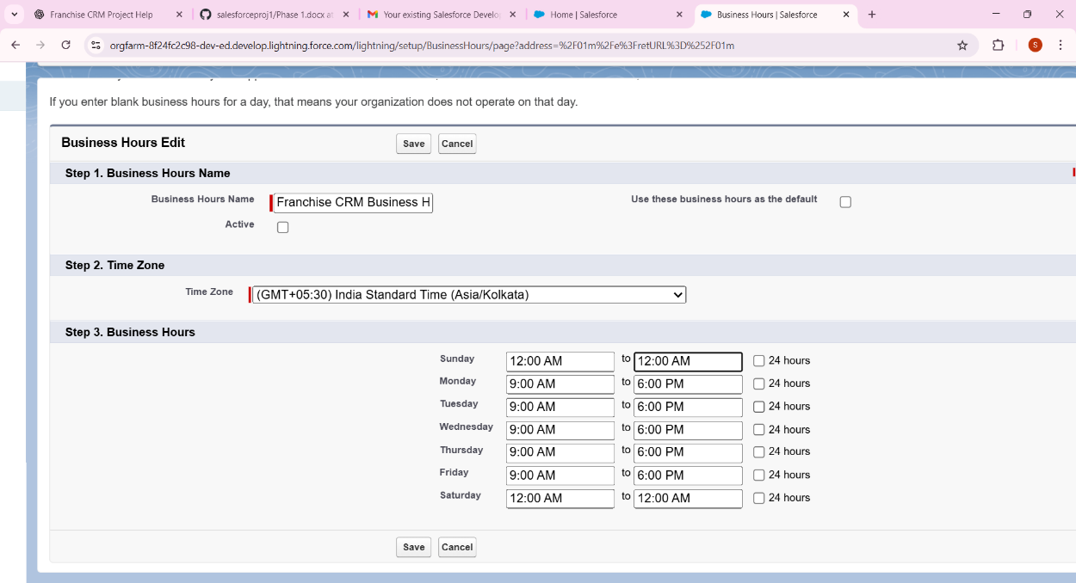

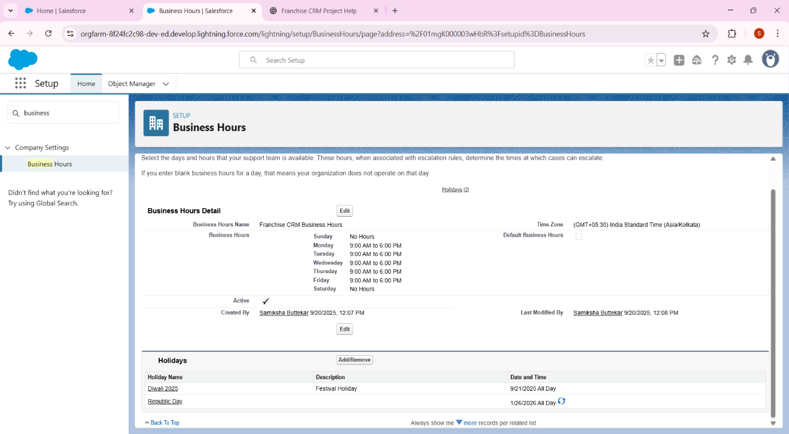

**4 Fiscal Year**

* In Setup → Search **Fiscal Year**.
* Keep Standard (Jan–Dec) selected.

1. **Standard Fiscal Year** → default option, runs Jan–Dec.
   * Start month: January
   * Fiscal year name: based on ending month (so 2025 fiscal year means Jan–Dec 2025).
   * Recommended for your project (simple, no errors).
2. **Custom Fiscal Year** → used if the company runs on Apr–Mar (like Indian financial year) or other variations.
   * More complex, requires enabling custom fiscal years.

**5: User Setup & Licenses**

* In Setup → Search Users.
* Click New User. Create:
  1. *Outlet Manager* – License: Salesforce, Profile: Standard User.
  2. *Franchise Owner* – License: Salesforce, Profile: System Administrator (if needed).

### ****Step-by-Step for Creating “Outlet Manager” User****

1. **First Name:**  
    Outlet
2. **Last Name (Required):**  
    Manager
3. **Role:** Leave it <None Specified> for now (we’ll assign roles later in the hierarchy setup).
4. ***User License (Required):*** *Select Salesforce*
5. **Alias (auto-fills usually):**  
    Keep as suggested (e.g., outletm).
6. Profile (Required):  
   Choose Standard User (sufficient for Outlet Manager access).
7. Email (Required):  
   Use your own email (e.g., outletmanager.yourname@gmail.com) so that Salesforce sends the activation email to you.
8. Active:  
   Keep it checked
9. Username (Required):  
   Must be unique across all Salesforce orgs. Format like an email. Example:  
   outletmanager.crmproject2025@gmail.com  
   ( It doesn’t have to be a real Gmail, just a unique email-style format. But easier if you use your own Gmail.)
10. Nickname:  
    Auto-fills (keep as it is)
11. **Other Checkboxes:**
12. **Marketing User:** Leave unchecked (not needed).
13. **Offline User / Knowledge User / Service Cloud User:** Leave unchecked.
14. **Flow User:** Keep checked (needed if this user will run automation/flows).
15. **Company / Department / Division:**  
    Optional – you can leave blank for now.
16. **Save.**

* 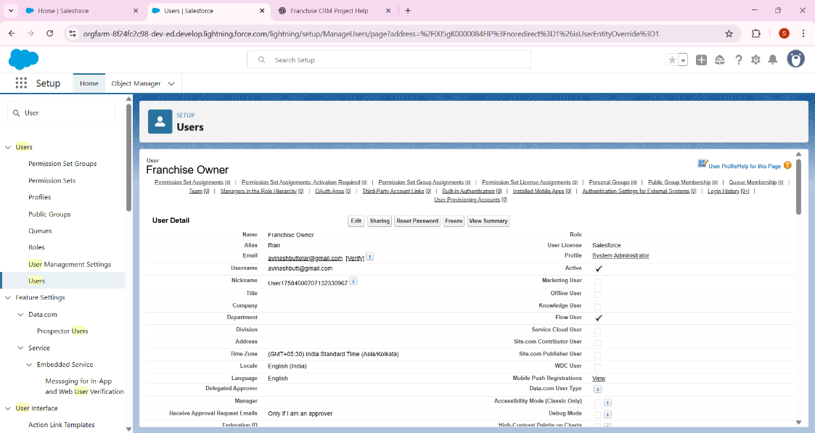

**6: Profiles**

* In Setup → Search Profiles.
* Clone Standard User → Name it *Outlet Manager Profile*.
  + Permissions: Can create & edit Outlets, Sales Records, Compliance Records.
* For Franchise Owner Profile → Give full access.

### Step 1: G to Profiles

1. Click the ⚙️ **Setup (gear icon) → Setup.**
2. In Quick Find → search **Profiles.**
3. You’ll see the list of profiles (like in your screenshot).

### 🔹 Step 2: Open a Profile

1. Click on the **Profile Name** (example: Standard User, or your cloned Outlet Manager Profile).  
   ⚠️ Don’t click Edit | Clone on the right — instead click the **blue link of the profile name itself**.

### 🔹 Step 3: Find Object Settings

Now you’re on the **Profile Detail page.**Scroll down — you’ll see different sections like:

* Administrative Permissions
* App Permissions
* **Object Settings** (this is the one we need)

Click **Object Settings**, and you’ll get a list of objects (Accounts, Contacts, etc.).

### 🔹 Step 4: Edit Object Access

1. Click on the object name (example: Account).
2. Click **Edit.**
3. Select which permissions you want to allow:
   * Read
   * Create
   * Edit
   * Delete
   * View All / Modify All (for Franchise Owner profile).
4. Save.

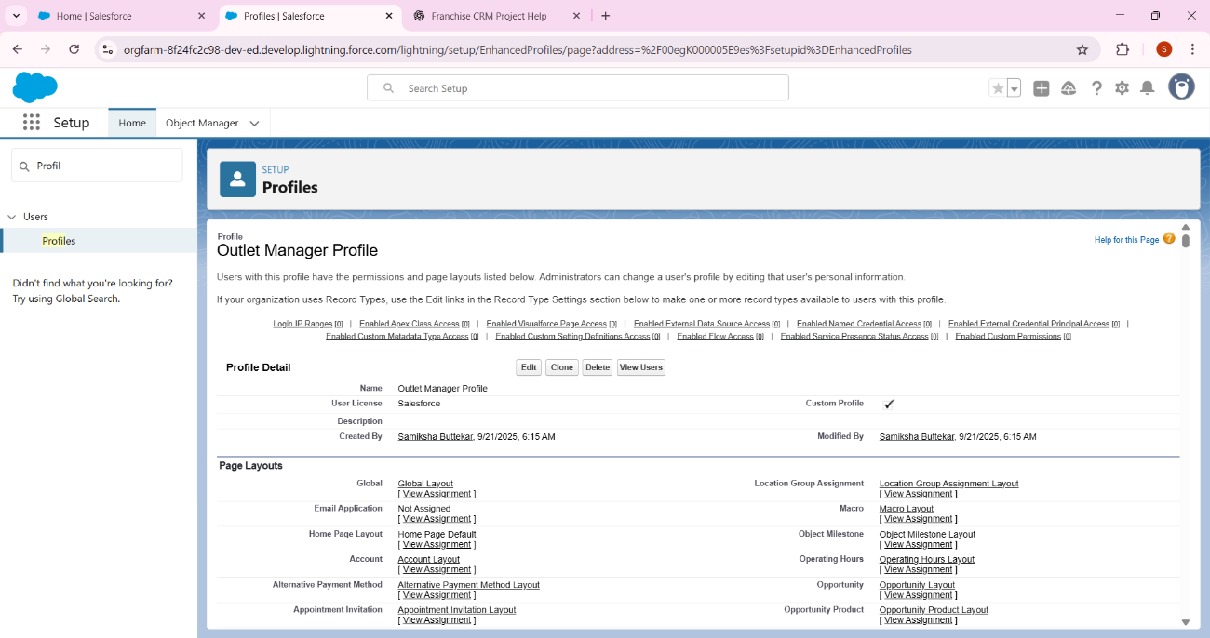

**7: Roles**

* In Setup → Search Roles → Set Up Roles.
* Create:
  + *Franchise Owner (top role)*
  + *Outlet Manager (child role)*
* Assign Outlet Managers to lower role.

**1: Go to Roles Setup**

1. In Salesforce, click the **⚙️ gear icon → Setup**.
2. In the Quick Find box, type Roles**.**
3. Select Roles → Set Up Roles.
   * You’ll now see a role hierarchy page with “CEO” at the top (default starting point).

**2: Create the Franchise Owner Role**

1. On the role hierarchy page, click the **Add Role** button (beside CEO).
2. Fill in details:
   * Label: Franchise Owner
   * Role Name**:** Franchise Owner
   * Parent Role**:** CEO (this will put Franchise Owner directly under CEO).
   * Leave the rest as default.
3. Click **Save**.

**3: Create the Outlet Manager Role**

1. Back on the role hierarchy page → find Franchise Owner.
2. Click Add Role under Franchise Owner.
3. Fill in details:
   * Label: Outlet Manager
   * Role Name**:** Outlet Manager
   * Parent Role: Franchise Owner
4. Save.

**4: Assign Users to Roles**

1. On the role hierarchy page → click the **“**Assign” link beside *Outlet Manager*.
2. From the available users list → select your Outlet Manager **user** and assign.
3. Do the same for Franchise Owner role → assign your “Franchise Owner” user.

**5: Verify Role Hierarchy**

* You should now see:

CEO

↳ Franchise Owner

↳ Outlet Manager

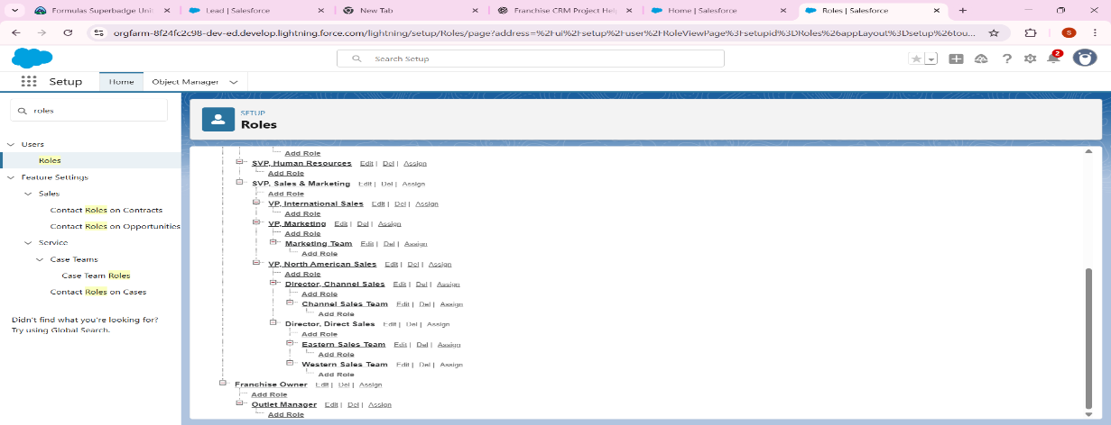

## 8: Permission Sets

* In Setup → Search **Permission Sets → New.**
* Name: Reports Access.
* Add extra access to Reports & Dashboards.
* Assign to Outlet Manager if needed.

**1: Create the Permission Set**

On the screen you shared:

1. Label**:** Reports Access  
   (API Name will auto-fill as Reports_Access).
2. Description (optional): Extra access to Reports & Dashboards.
3. License: keep as --None-- (because we want flexibility to assign this permission set to any user, regardless of their license).
4. Click Save.

**2: Add Report & Dashboard Permissions**

After saving, you’ll land on the **Permission Set Overview Page**.

1. Scroll down to the section System Permissions.
2. Click System Permissions → Edit.
3. Tick these checkboxes:
   * Run Reports
   * Create and Customize Reports
   * View Dashboards in Public Folders
   * Create and Customize Dashboards (optional, if you want managers to make dashboards)
4. Click **Save**.

**3: Assign the Permission Set**

1. On the permission set page, click Manage Assignments.
2. Click Add Assignments.
3. Select your Outlet Manager user(s).
4. Click Assig**n** → Done.

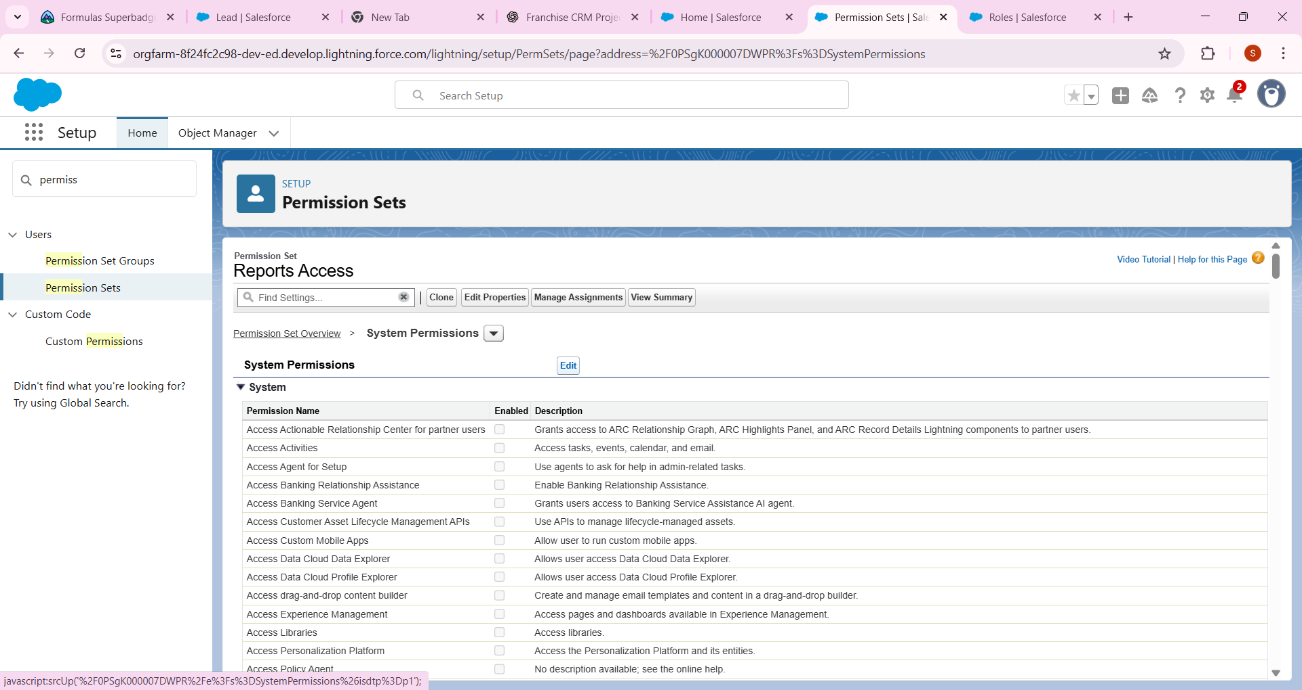

## 9: Org-Wide Defaults (OWD)

* In Setup → Search **Sharing Settings**.
* Change:
  + **Outlets** → Public Read Only.
  + **Sales Records** → Private.
  + **Compliance Records** → Private.

**1: Open OWD**

You already did this ✅ (Setup → Search → **Sharing Settings** → Organization-Wide Defaults).

**2: Find Your Objects**

Scroll in the Object column until you locate the objects you need to adjust. In your case, the instructions say:

* Outlets → Public Read Only
* Sales Records → Private
* (Compliance Records → Private as per your notes)

These are the custome object

* Outlets__c
* Sales_Records__c
* Compliance_Records__c

**3: Change Defaults**

For each custom object:

1. Click Edit (at the top of the OWD table).
2. In the Default Internal Access column:
   * Set Outlets__c → Public Read Only
   * Set Sales_Records__c → Private
   * Set Compliance_Records__c → Private
3. Leave Grant Access Using Hierarchies checked (unless instructed otherwise).
4. Save.

**4: Verify**

After saving, scroll back to the OWD list and confirm that:

* Outlets = Public Read Only
* Sales Records = Private
* Compliance Records = Private

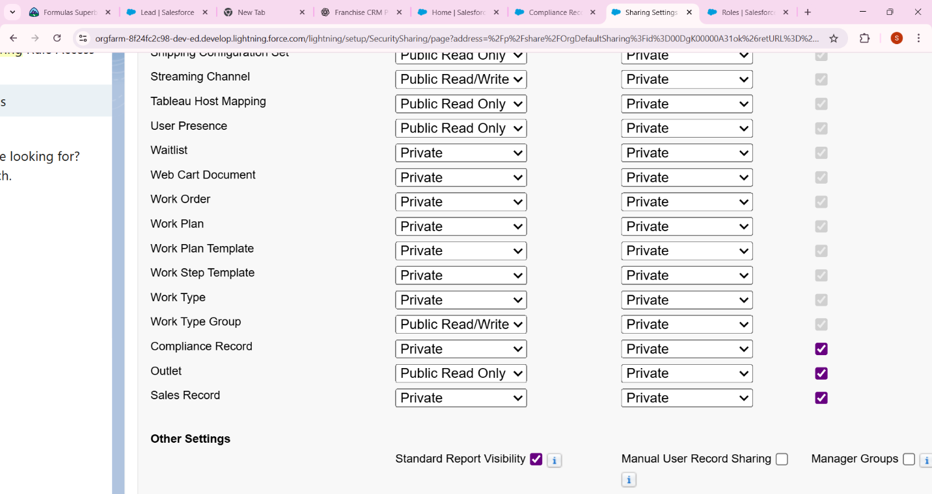

**10: Sharing Rules**

* In Setup → **Sharing Settings** → Create Sharing Rule.
* Example: Share **Sales Records** with all Outlet Managers.

Example:

* **Label:** Share Sales Records with Outlet Managers
* **Rule Name (API):** Share_Sales_Records_Outlet_Managers (auto fills)
* **Rule Type:**
  + If you want to share **based on record ownership**, select **Based on record owner**.
  + If you want to share **all Sales Records that meet certain criteria**, choose **Based on criteria**.  
    👉 In your case, usually “Based on record owner” is simplest.

## Configure Rule Access

* **Share Records Owned By: (e.g**., Franchise Owner**,** or All Users in Role FranchiseOwner **–** depends on your hierarchy**)**
* **With: Role = Outlet Manager**
* **Access Level:** Read/Write (so they can edit Sales Records).

## 5: Save & Recalculate

* Click **Save**.
* Salesforce may ask you **to Recalculate Sharing** – confirm Yes.

## 

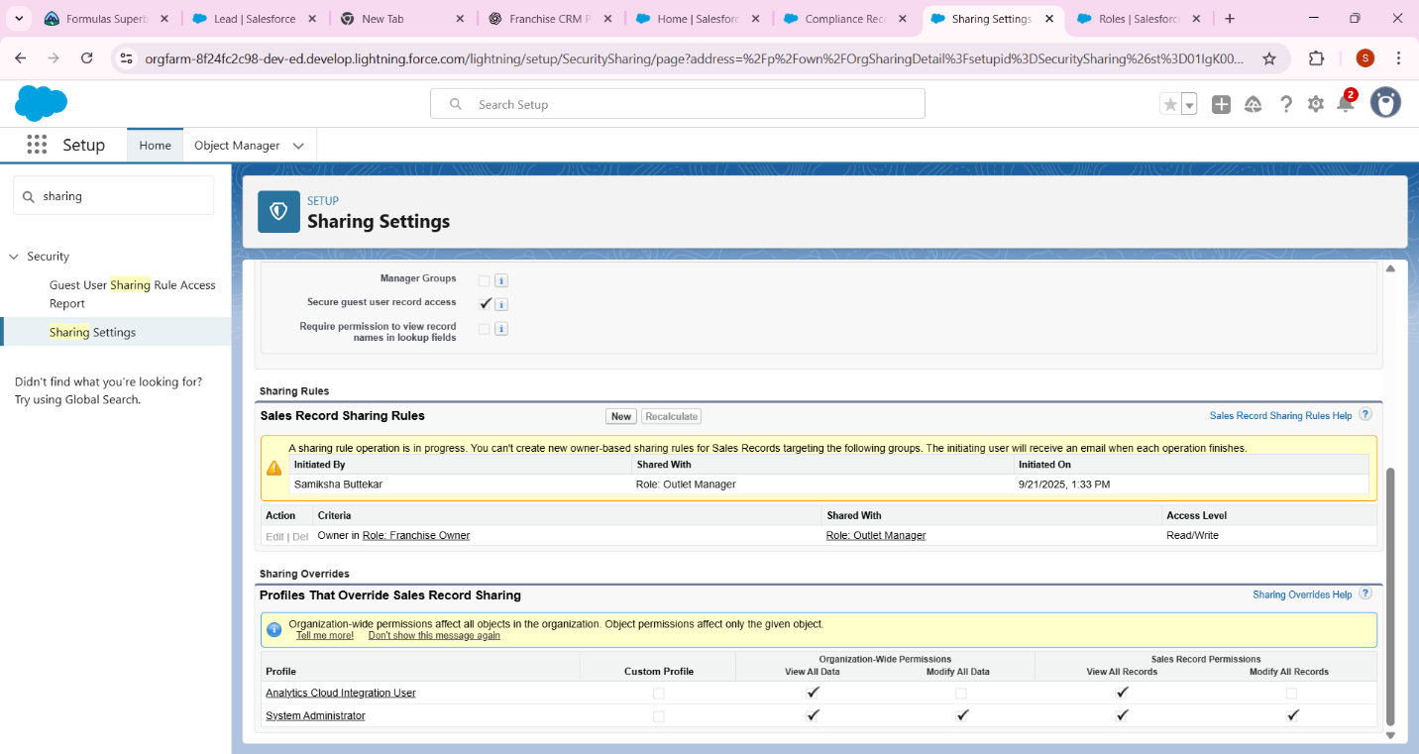

## Step 11: Login Access Policies

* In Setup → Search **Profiles →** Edit Outlet Manager Profile.
* Restrict Login Hours → 9 AM – 6 PM.

## Step-by-Step: Restrict Login Hours for Outlet Manager Profile

1. **Go to Setup**
   * In the **Quick Find** search box, type **Profiles**.
   * Click **Profiles**.
2. **Select the Profile**
   * Find the **Outlet Manager Profile** (the one you created earlier).
   * Click **Edit**.
3. **Scroll to Login Hours**
   * In the profile settings page, scroll down until you find a section called **Login Hours**.
   * By default, it may be “None” (meaning unrestricted).
4. **Set Hours**
   * You’ll see a table with **Days of the Week** and **Start Time – End Time**.
   * For **Monday → Sunday**, set:
     + **Start Time:** 9:00 AM
     + **End Time:** 6:00 PM
   * Leave it blank (None) if you want to block access entirely on certain days.

⚡ Example:

| **Day** | **Start Time** | **End Time** |
| --- | --- | --- |
| Monday | 9:00 AM | 6:00 PM |
| Tuesday | 9:00 AM | 6:00 PM |
| … | … | … |
| Sunday | 9:00 AM | 6:00 PM |

1. **Save**
   * Click **Save** at the bottom.

Result: Now Outlet Managers **cannot log in before 9 AM or after 6 PM**. If they try, Salesforce will show them a **Login Hours Restriction error**.

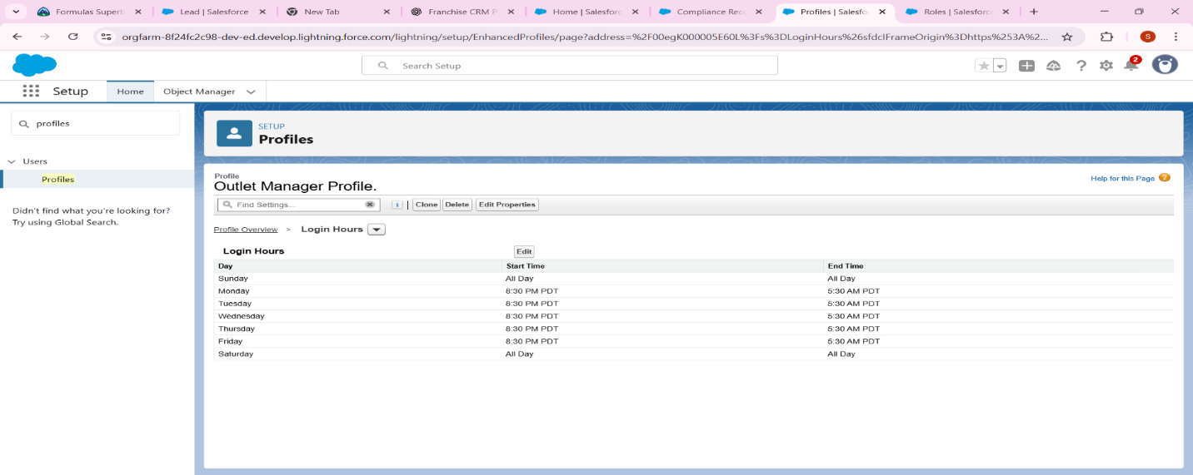

## **Step 12: Developer Org Setup (Sandbox Concept**)

* Note: Developer Edition **acts as sandbox** for your project.
* In real companies: Build in Sandbox → Deploy to Production.

**Understanding the Concept**

* In real companies, people don’t build directly in Production Org (the live system used by customers).
* They use a Sandbox (a copy of Production) or a Developer Org (like the free one you’re using) for safe development & testing.
* Once tested, changes are **deployed** to Production.

For your project:

* Your (the one you signed up with) **acts as a Sandbox**.
* That’s why you don’t need to create a separate Sandbox.

**What You Need to Do for This Step**

1. Go to Setup Home
   * Click the **gear icon** (⚙️) → Setup.
2. Check the Org Name
   * At the top of the Setup Home page, you’ll see something like:  
     Franchise Management CRM Pvt Ltd (Developer Edition)
   * The words Developer Edition confirm this is already your sandbox-like environment.

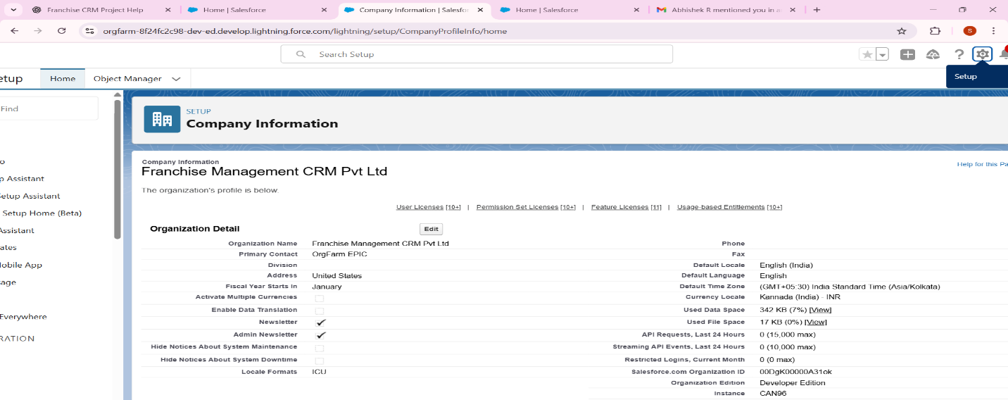

## Step 13: Deployment Basics

* Mention in report: Deployment is done using **Change Sets** or **Salesforce CLI**.
* No action needed in free Dev Org, just theory.

# **Phase 3: Data Modeling & Relationships**

Franchise Management CRM Project

Goal: Build the data structure for Franchise CRM.

## 1. Standard & Custom Objects

Standard Object:  
 - Contact → Customers of franchise outlets.  
 Custom Objects:  
 - Outlet • → Represents each franchise outlet.  
 - Order → Represents sales/bookings made at an outlet.  
  
Hands-on:  
1. Go to Setup → Object Manager → Create → Custom Object.  
 - Object Label: Outlet  
 - Object Name: Outlet__c  
 - Record Name: Auto Number or Text (Outlet ID).  
2. Create another custom object:  
 - Object Label: Order  
 - Object Name: Order__c  
 - Record Name: Auto Number (Order-0001, Order-0002…).

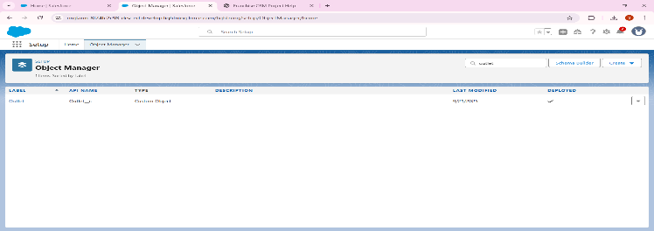

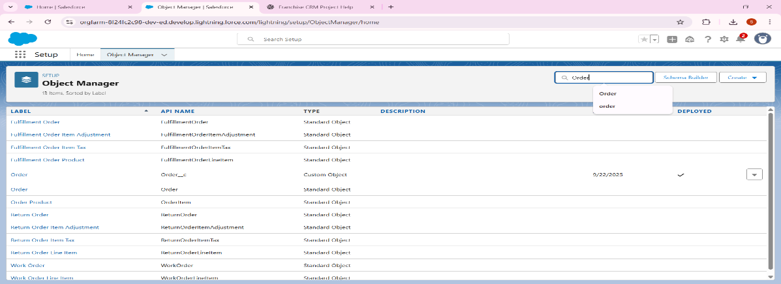

## **2. Fields**

• Outlet fields:  
 - Location (Text)  
 - Opening Date (Date)  
 - Status (Picklist: Active, Inactive)  
  
• Order fields:  
 - Order Date (Date)  
 - Amount (Currency)  
 - Payment Status (Picklist: Paid, Pending, Cancelled)  
 - Lookup → Outlet (which outlet this order belongs to)  
 - Lookup → Contact (customer making the order)

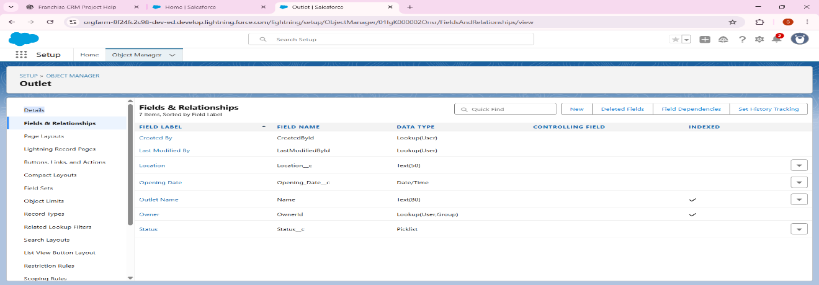

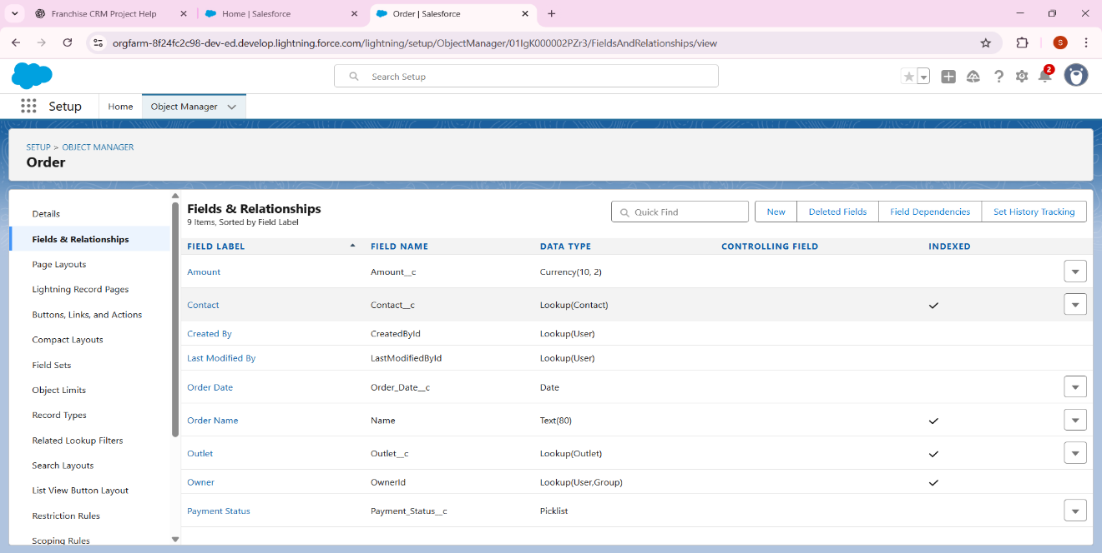

## 3. Record Types

• For Orders create two record types:  
 - Walk-in Order  
 - Online Order  
  
Hands-on:  
1. Go to Object Manager → Order → Record Types → New.  
2. Create two record types and assign to profiles (Outlet Manager).

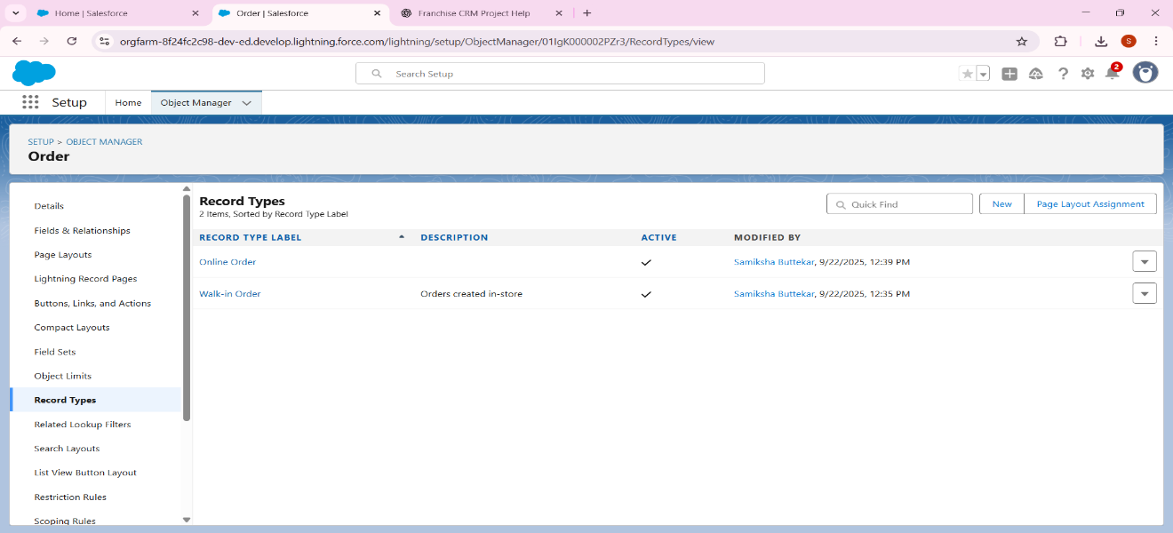

## 4. Page Layouts

• Outlet Page Layout: Show Outlet details + related list of Orders.  
• Order Page Layout: Show Order details + related Outlet & Customer.

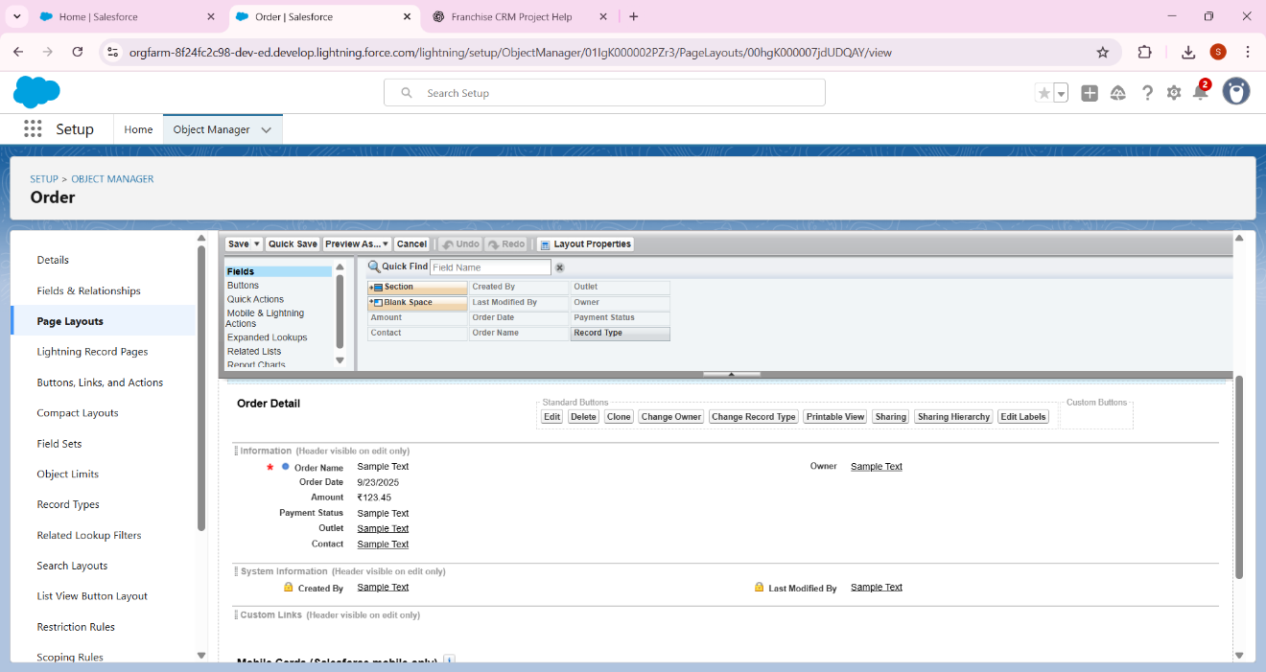

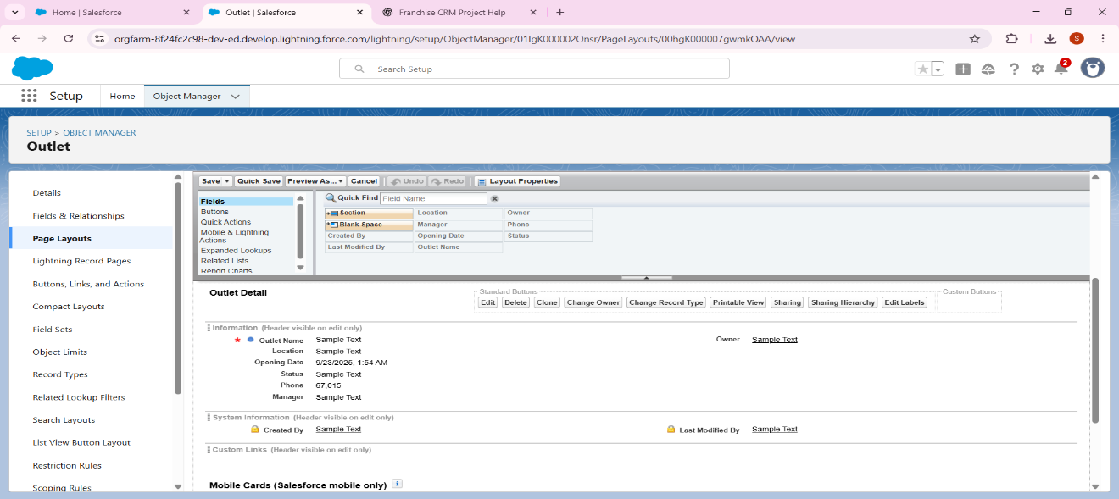

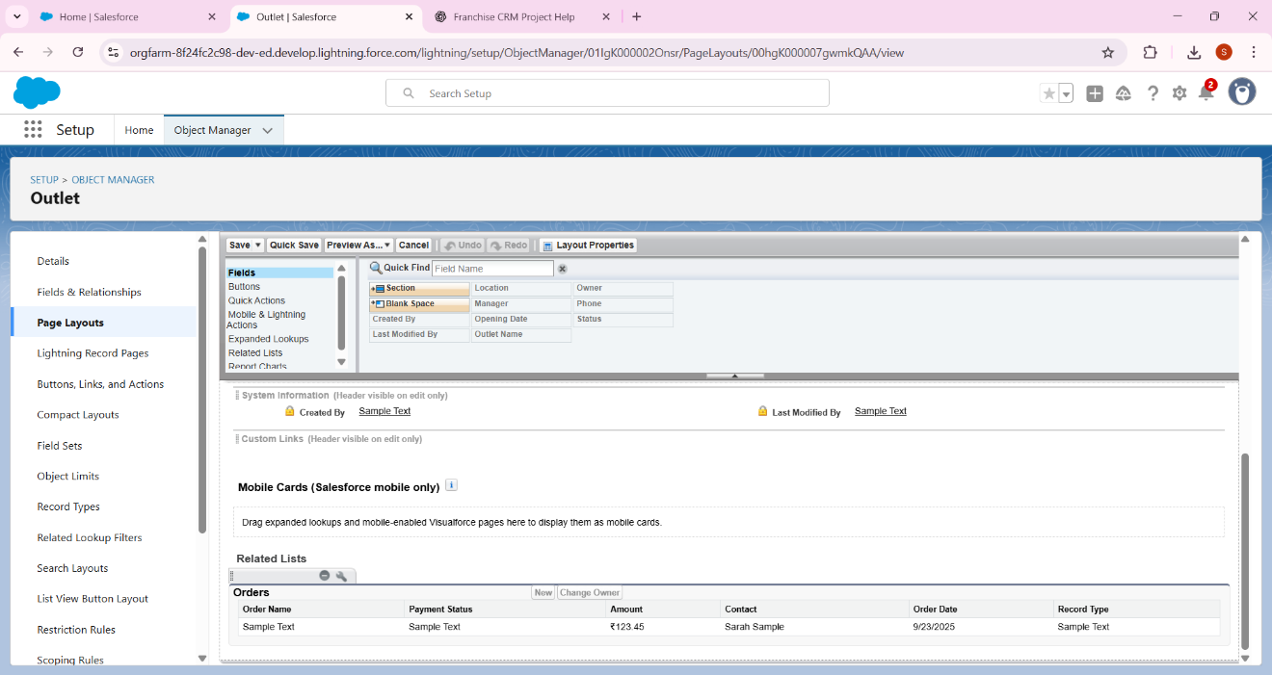

## 5. Compact Layouts

• Outlet Compact Layout (for Mobile): Show Name, Location, Status.  
• Order Compact Layout: Show Order Date, Amount, Payment Status.

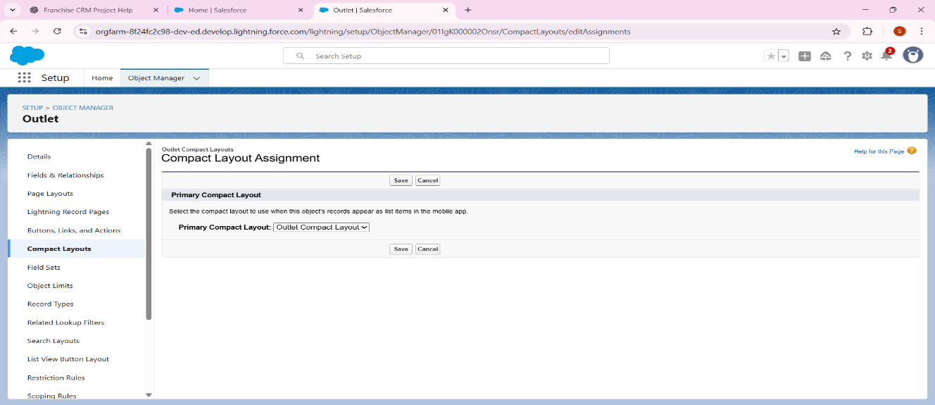

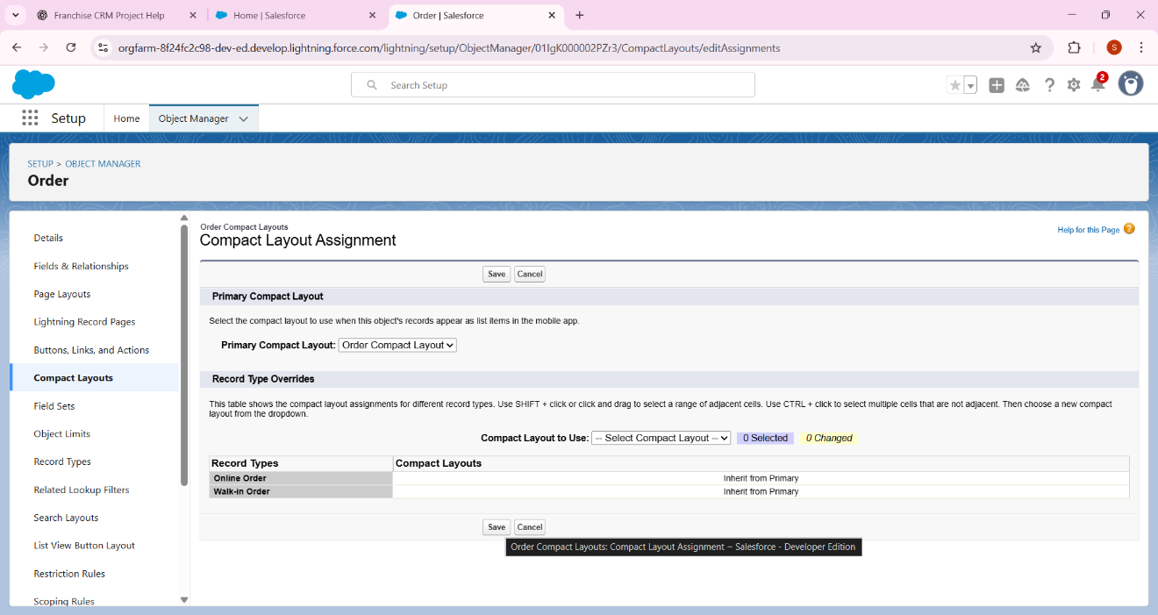

### **.**6 Schema Builder****

* Go to **Setup → Schema Builder**.
* Drag objects (Outlet, Order, Contact).
* Draw relationships:
  + **Outlet → Orders (Master-Detail)**
  + **Orders → Contact (Lookup)**
* 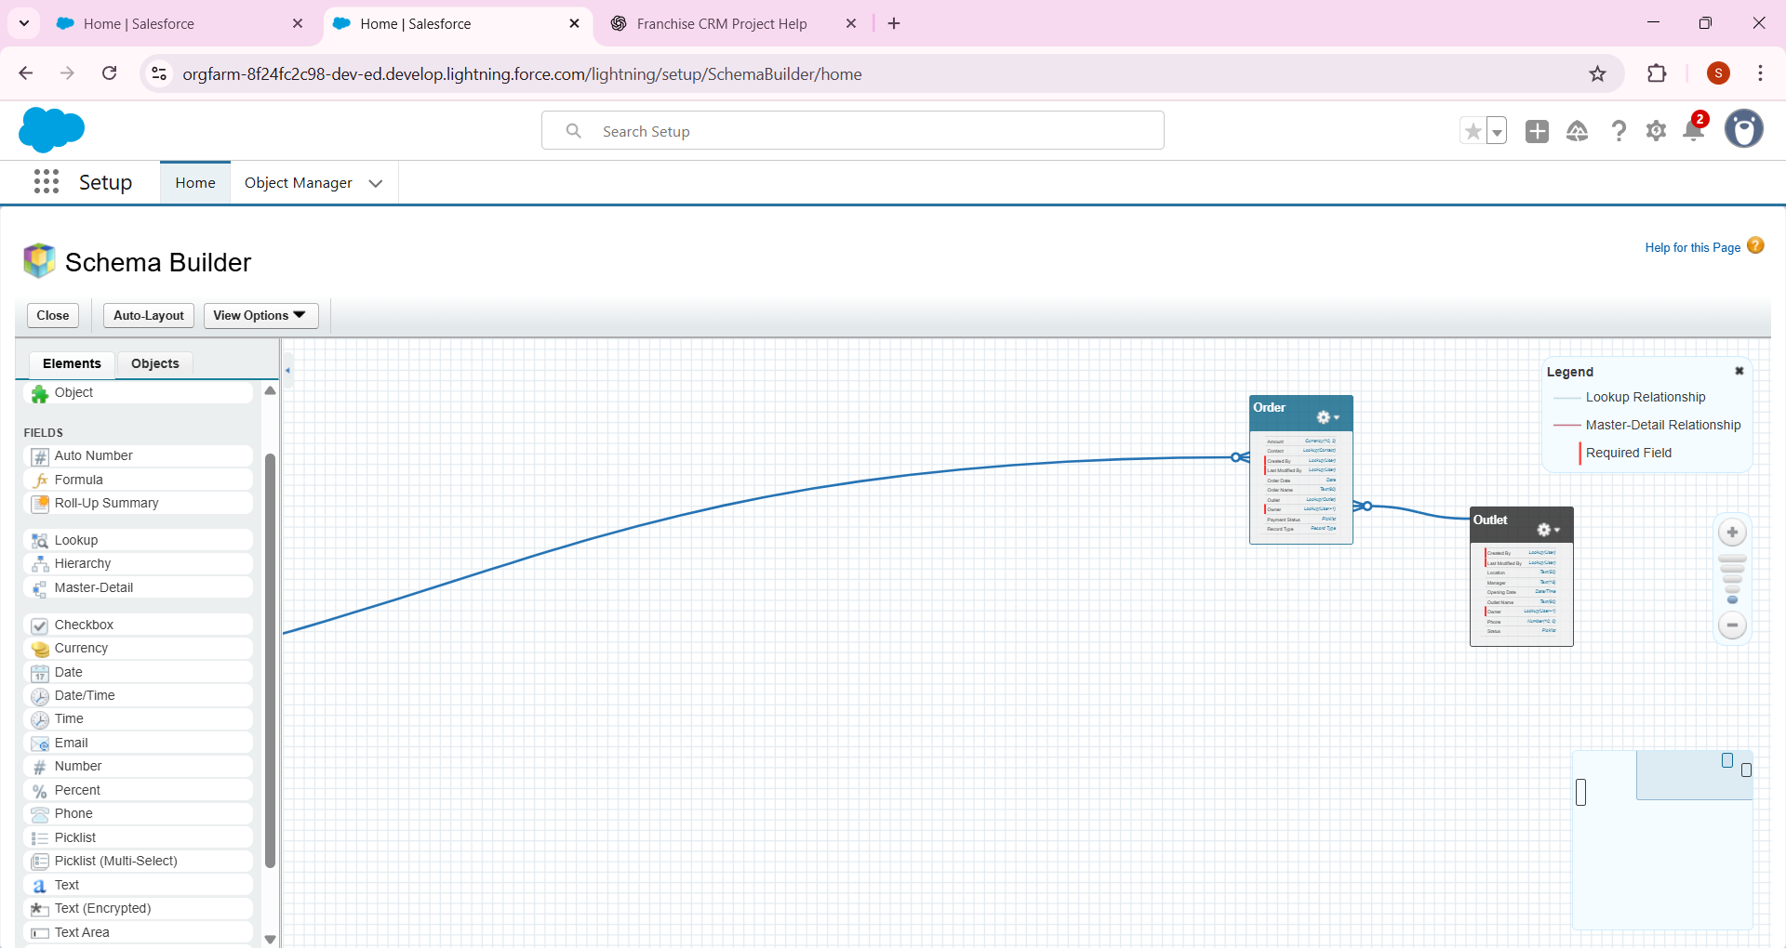

## 7. Lookup vs Master-Detail vs Hierarchical

* Outlet ↔ Orders: : Lookup Relationship
* Order ↔ Contact: Lookup (order may exist even if no contact linked).  
   Hierarchical: Only applies for Users (already covered in Phase 2 role hierarchy).

## 8. Junction Objects

• Not required here.  
• If one order could belong to multiple outlets, we’d create a junction object.

## 9. External Objects

• If franchise used external payment DB or inventory DB, we’d bring it as an External Object.  
• For now, not implemented.

# **Phase 4: Process Automation (Admin) – Franchise Management CRM**

🎯 Goal: Automate key franchise operations to reduce manual work.

## **1. Validation Rules**

Example: Sales Record → End Date must be after Start Date  
- Setup → Object Manager → Sales Record → Validation Rules → New.  
- Rule Name: EndDate_After_StartDate  
- Formula: End_Date__c < Start_Date__c  
- Error Message: “End Date must be after Start Date.”  
- Error Location: End Date field.

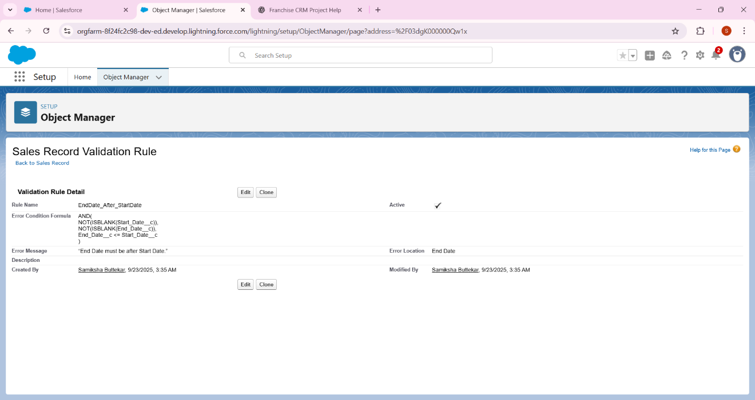

## **2. Workflow Rules (Legacy)**

Salesforce recommends Flow now, but you can create one for awareness.  
Example: When Compliance Record = Non-Compliant, send an auto email.

1. Click New Email Alert (top of the page).
2. Fill the form:
   * Description / Label → Example: Booking Confirmation Alert.
   * API Name → Auto-fills (leave it).
   * Object → Select the object you want this email tied to (e.g., Sales Record or your custom Booking__c).
   * Email Template → Choose an existing email template (or you can create one in Setup → Classic Email Templates if none exist yet).
   * **Recipients**:
     + You can add User, Role, or Related Contact.
     + For your Franchise Management CRM project, pick something like **Outlet** Manager Role or Franchise Owner.
3. **Save**

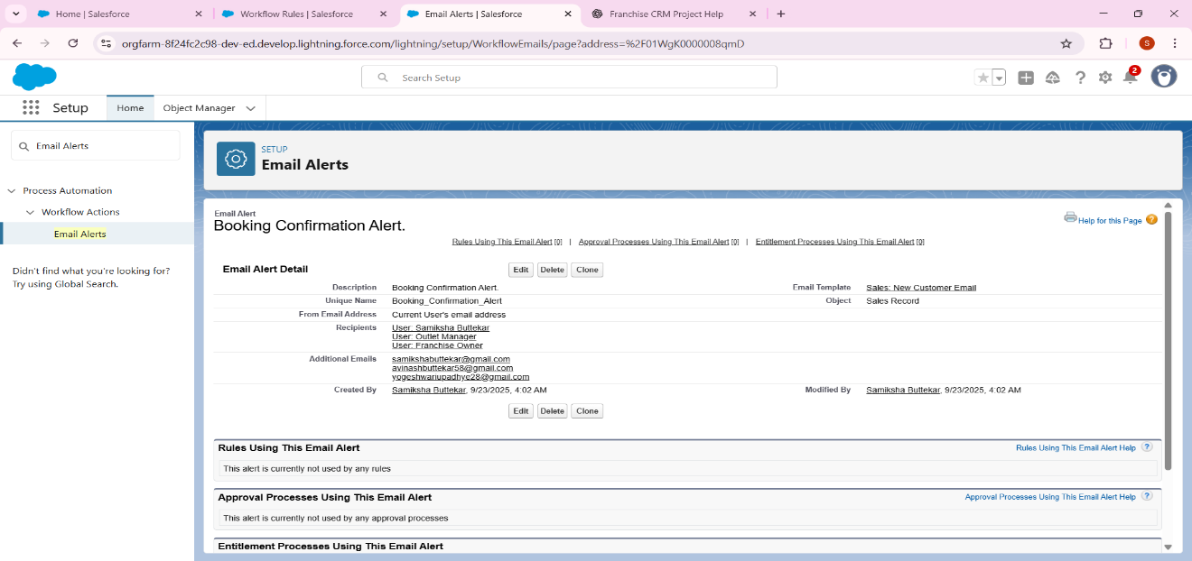

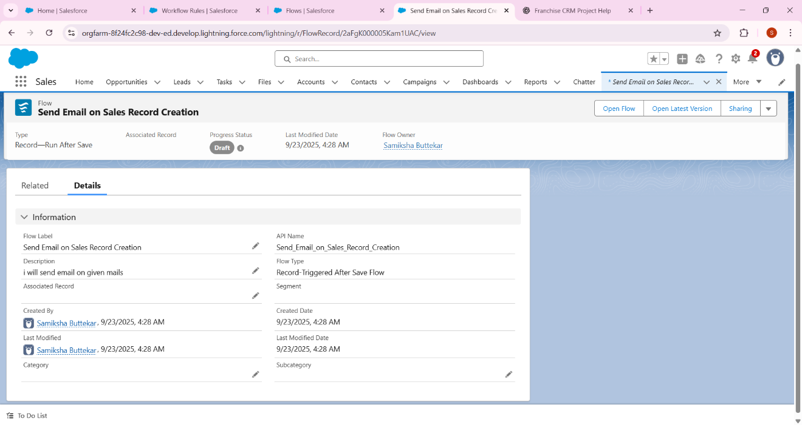

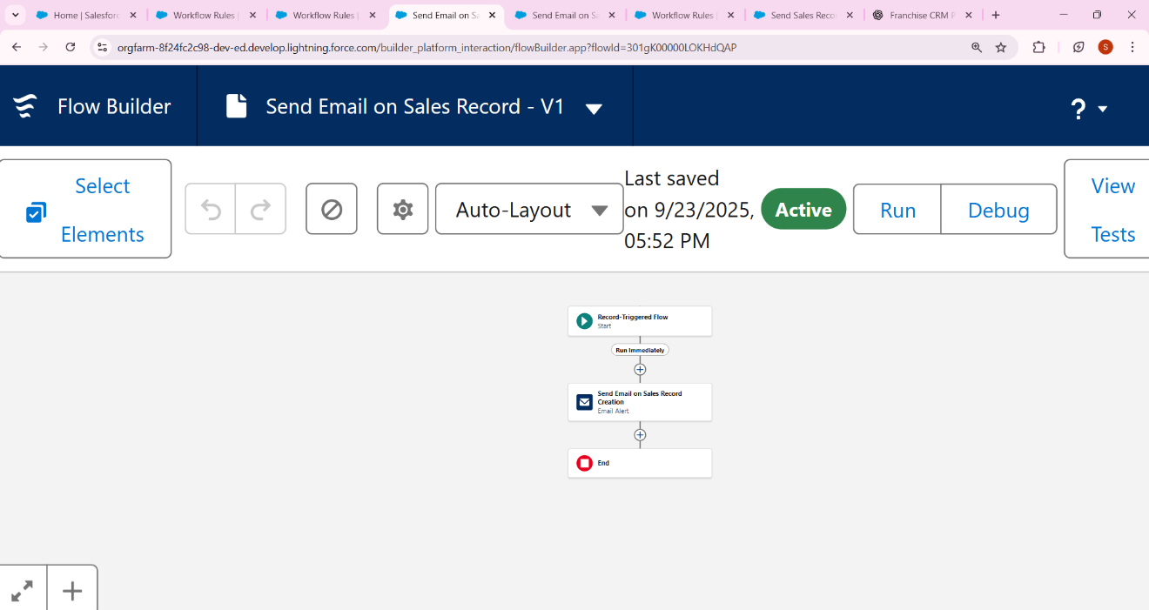

## **3. Process Builder (Legacy – awareness only)**

* Example: Auto-update **Compliance Status → “Needs Review”** if flagged.
* But Salesforce is replacing this with Flow.
* Just note this step; no need to build if Flow is enough

## **4. Approval Process**

Example: If Sales Record > ₹10,000 → send for Manager Approval.  
- Setup → Approval Processes → Object: Sales Record.  
- Name: High_Value_Sales_Approval  
- Criteria: Amount__c > 10000  
- Step 1 Approver: Franchise Owner  
- Final Action: Approve → Status = Approved, Reject → Status = Rejected.

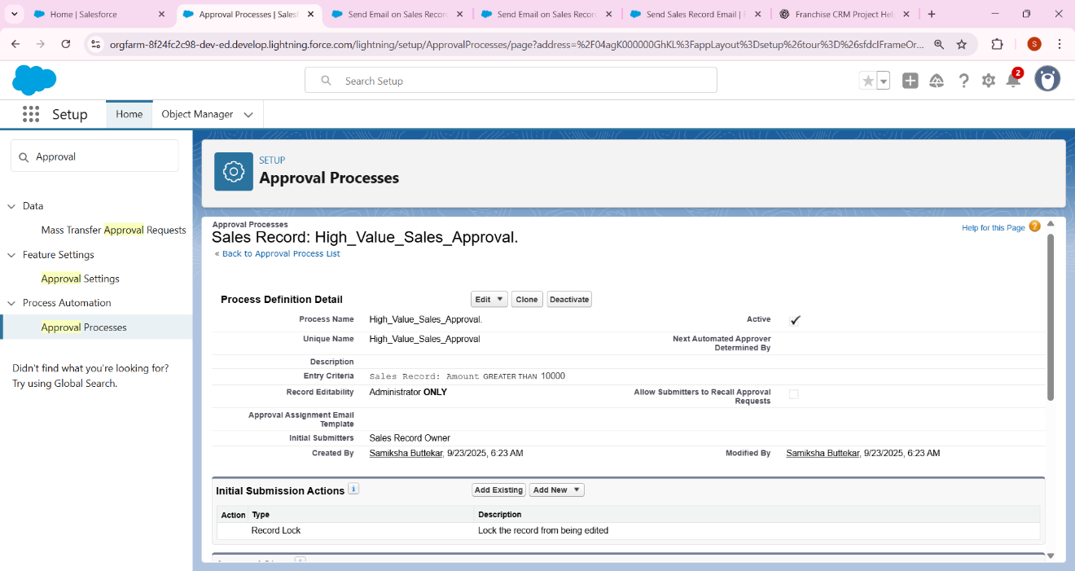

## **5. Flow Builder**

a) Record-Triggered Flow → Auto-calculate Total Amoun

### Record-Triggered Flow

* Example: When Sales Record is created → **Auto calculate Total Amount**.
  + Setup → Flow → New Flow → Record-Triggered Flow.
  + Object: Sales Record.
  + Trigger: On Create.
  + Add Assignment Element:
  + Total_Amount__c = Quantity__c * Price__c
  + Save & Activate

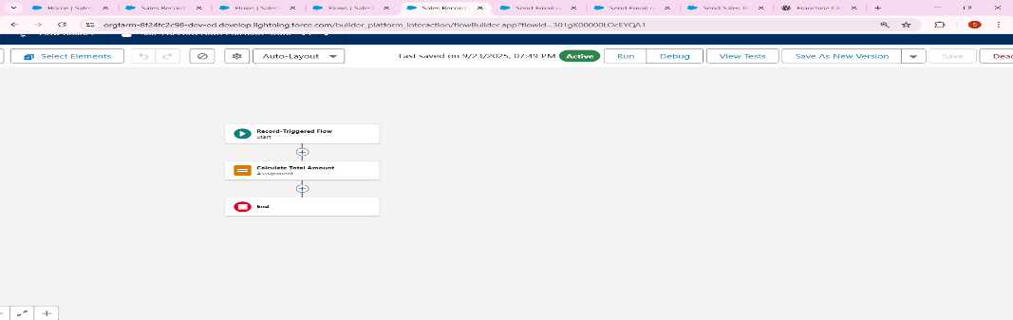

b) Screen Flow → Franchise Outlet Registration Form.

### (b) Screen Flow

* Example: **Franchise Outlet Registration Form.**
  + Setup → Flow → New Flow → Screen Flow.
  + Add fields: Outlet Name, Location, Manager.
  + On submit → Create Outlet record.
  + Save & Activate → Add to Lightning Page.

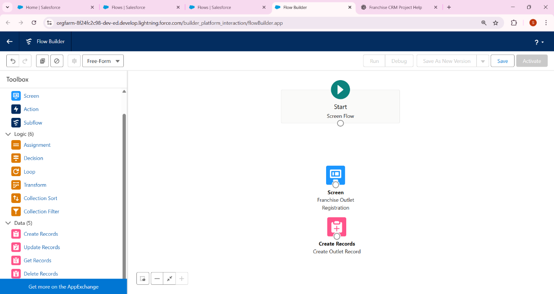

Example: After Approval of Sales Record → Email Customer.  
- Setup → Email Alerts → New → Template: 'Your Order as been Approved'.  
- Recipient: Contact related to Sales Record.

## **6. Email Alerts**

* Example: **After Approval of Sales Record → Email Customer.**
  + Setup → Email Alerts → New.
  + Template: “Your Order has been Approved”.
  + Recipient: Contact related to Sales Record.
  + Trigger via Approval Process or Flow.

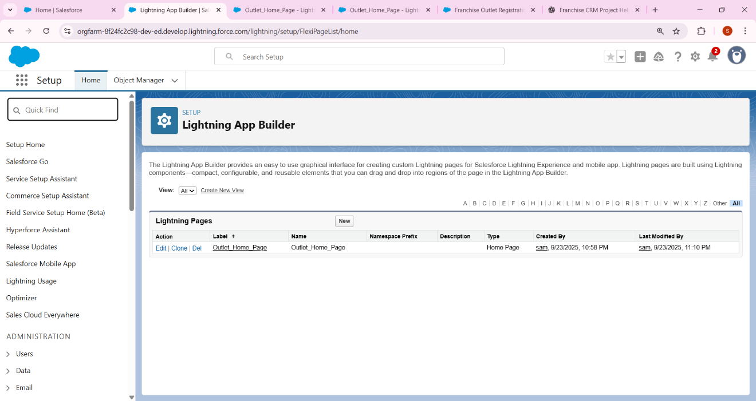

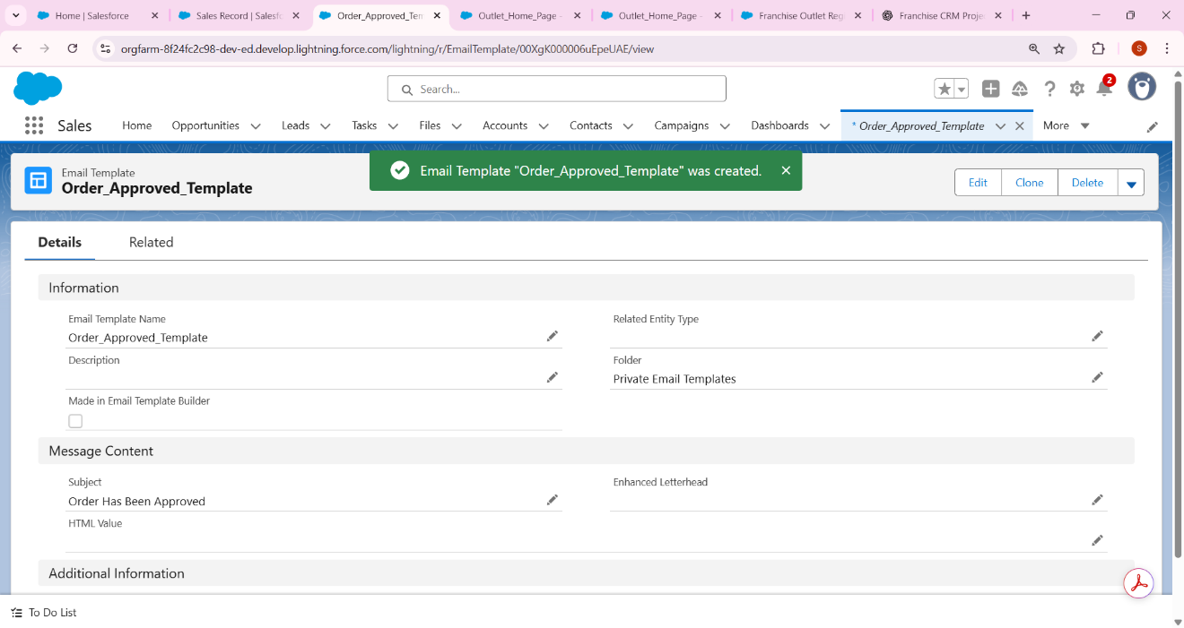

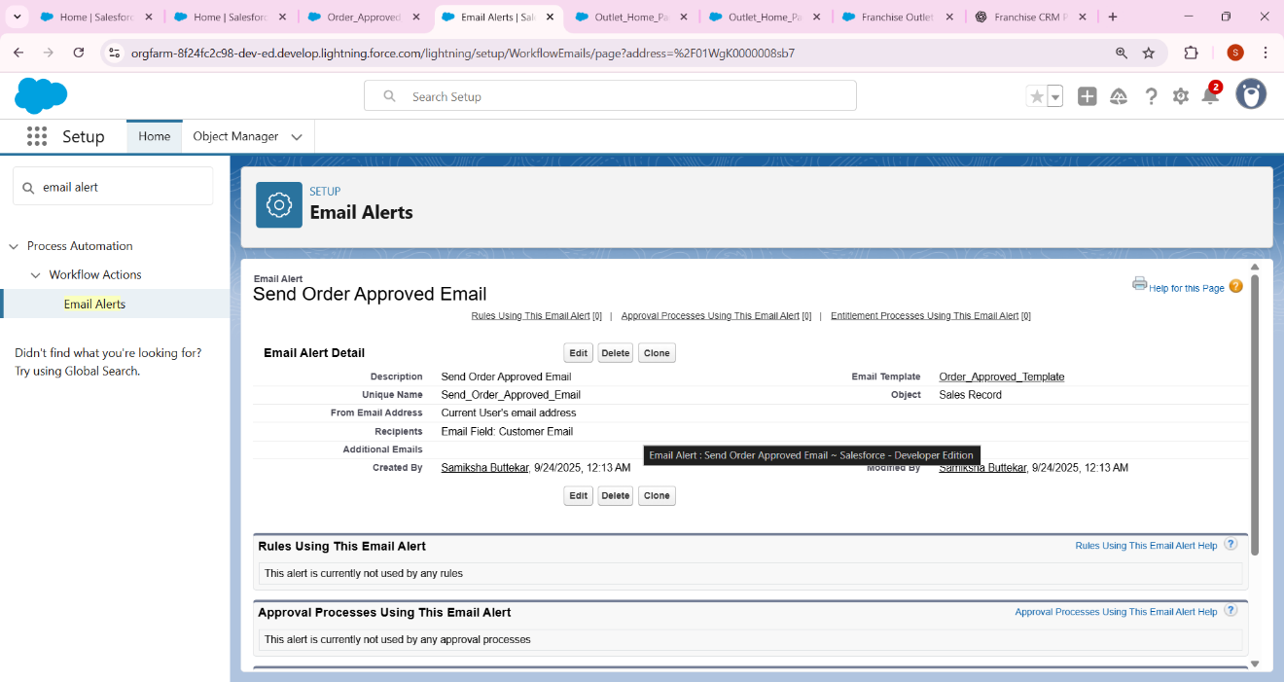

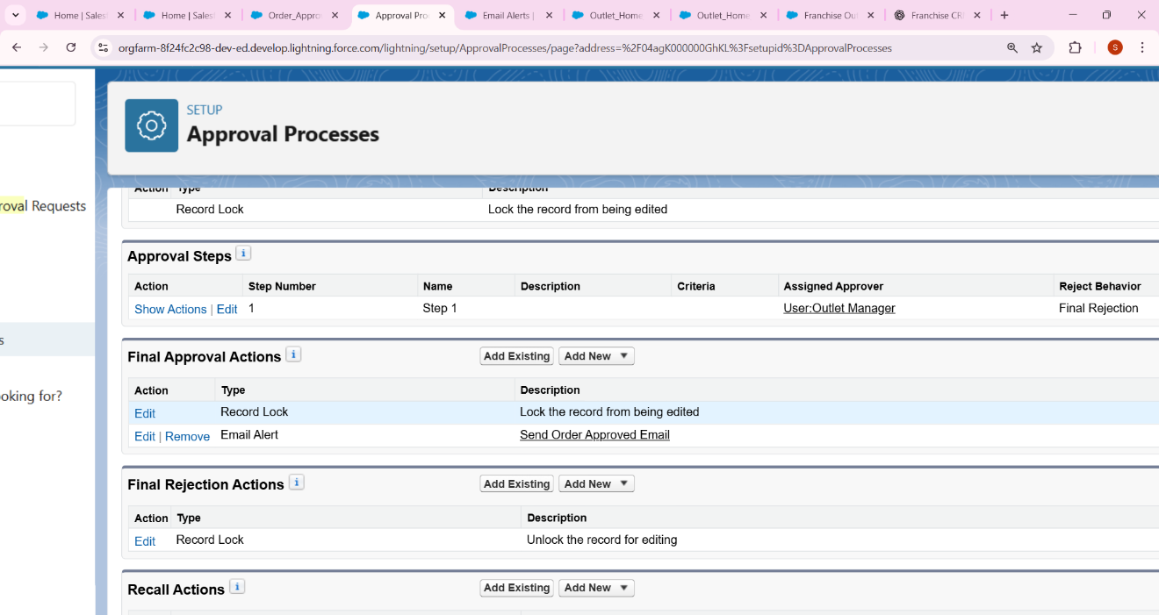

## **7. Field Updates**

Example: After approval, update Sales Status = Confirmed.  
- In Approval Process → Final Approval Actions → Add Field Update.

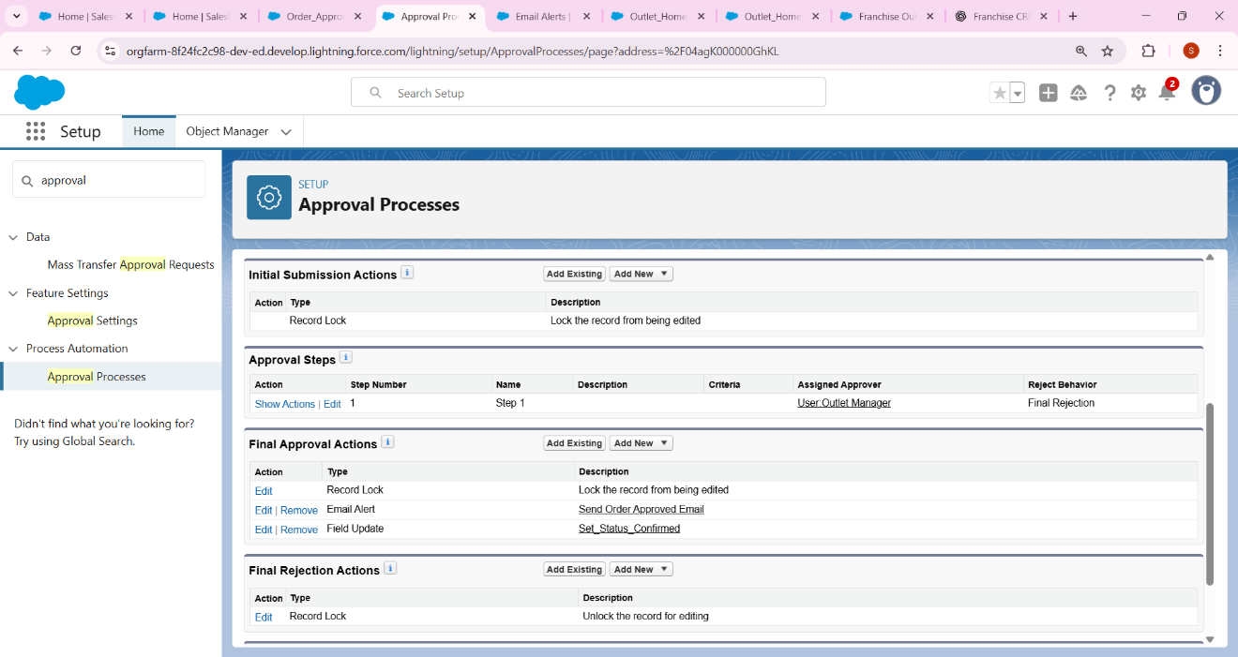

## 8. Tasks

Example: When Sales is Approved → Task for Outlet Manager.  
- Action → Create Task: 'Prepare Order for Customer.'

* Example: When Sales is Approved → Task for Outlet Manager.
  + Setup → Flow → After Approval.
  + Action → Create Task.
    - Subject: “Prepare Order for Customer.”
    - Assigned To: Outlet Manager.

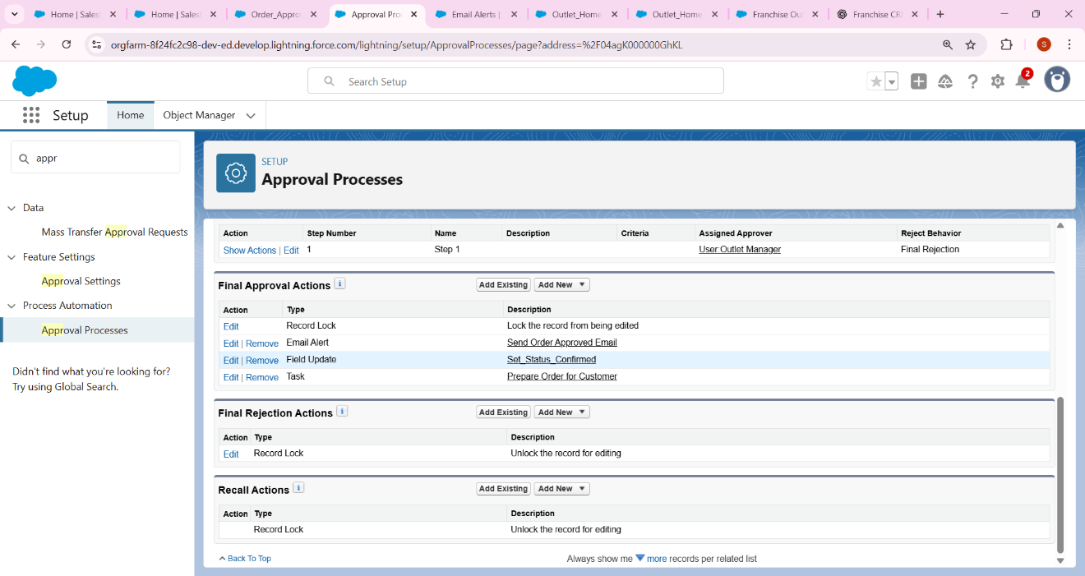

## 9. Custom Notifications

Example: Notify Franchise Owner when an Outlet is marked Non-Compliant.  
- Setup → Notification Builder → Custom Notification.  
- In Flow → Add Action → Send Custom Notification.

* Example: Notify **Franchise Owner** when an Outlet is marked “Non-Compliant.”
  + Setup → Notification Builder → Custom Notification → New.
    - Name: Compliance Alert.
  + In Flow → Add Action → Send Custom Notification.
    - Recipient: Franchise Owner.
    - Message: “Outlet XYZ marked Non-Compliant.”

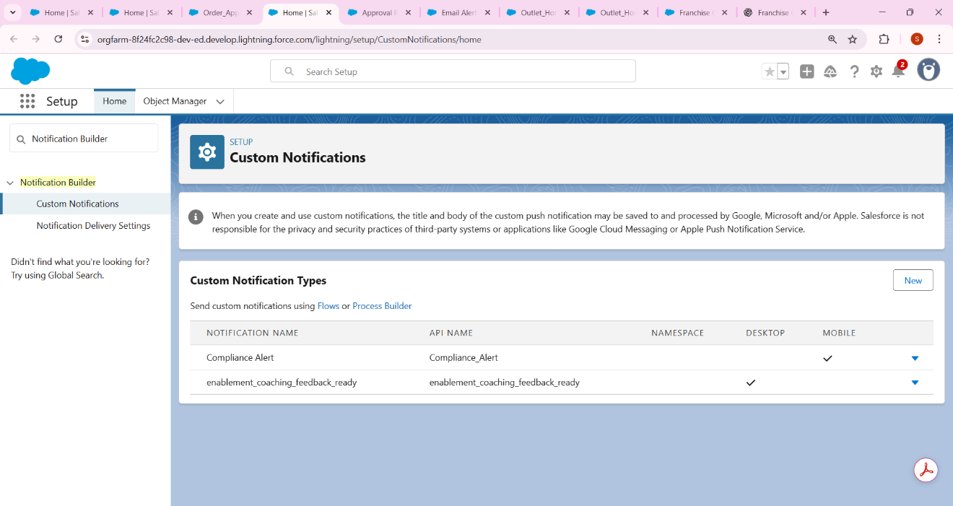

* Here we create outlet record name as pune outlet

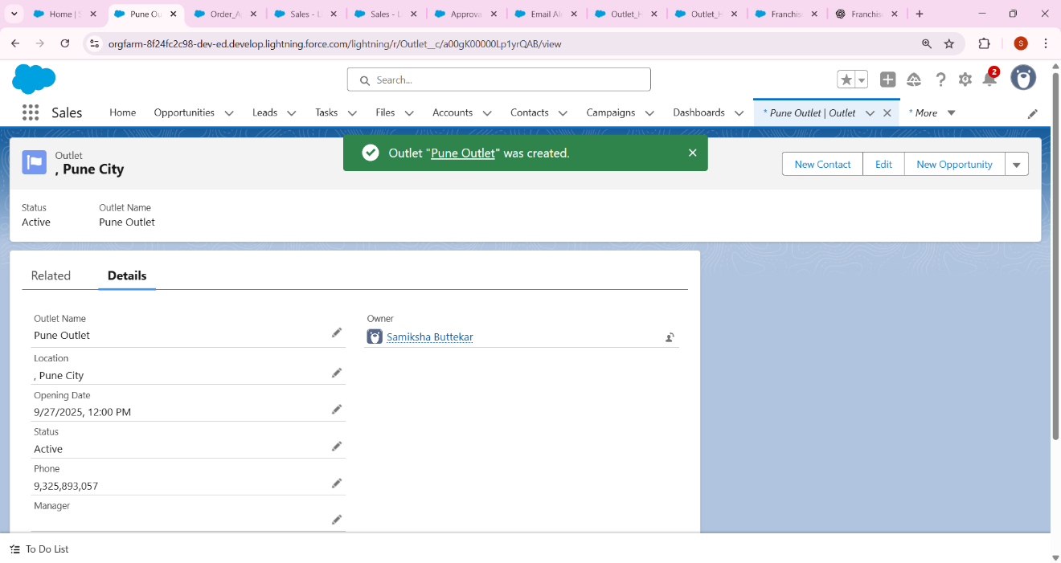

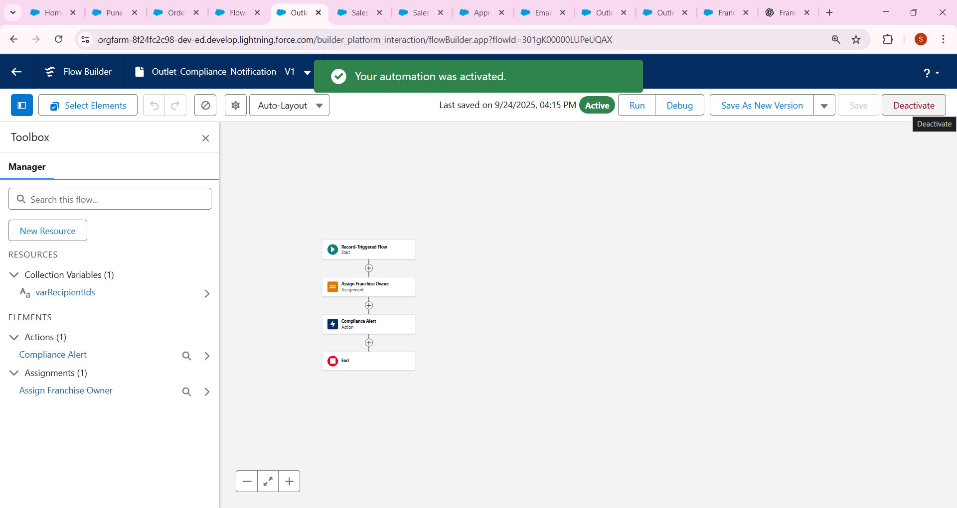

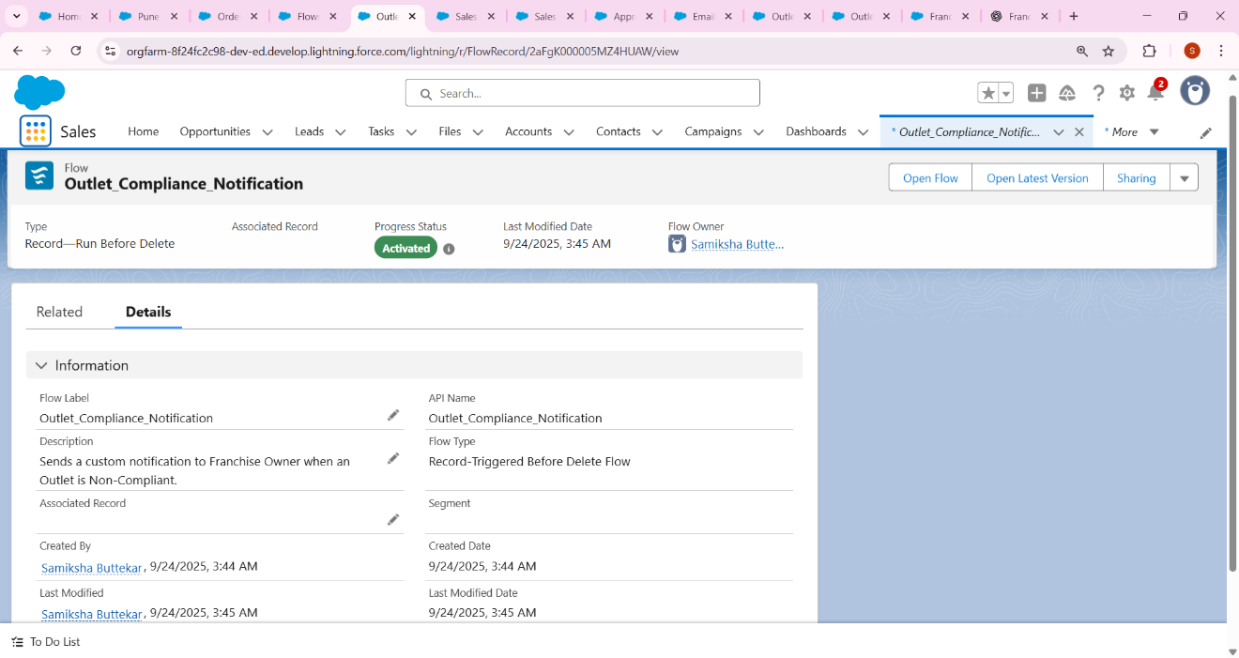

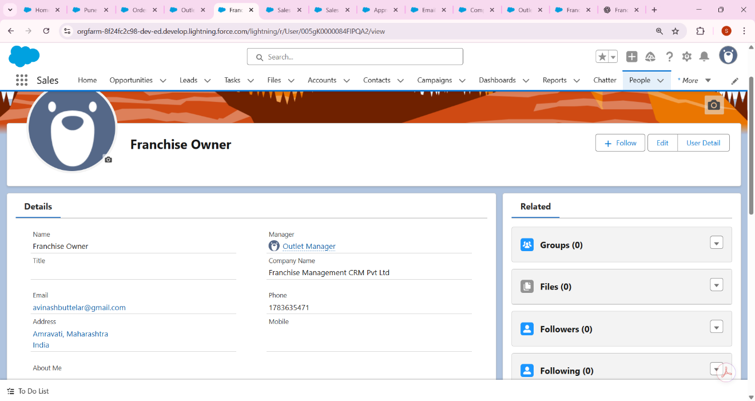

Phase 5 - Salesforce Apex Implementation

# 1. OrderService.cls

public with sharing class OrderService {  
  
 public static Map<String, Sales_Record__c> checkForDuplicateOrders(List<Sales_Record__c> newOrders) {  
 Map<String, Sales_Record__c> result = new Map<String, Sales_Record__c>();  
 if (newOrders == null || newOrders.isEmpty()) return result;  
  
 Set<Id> outletIds = new Set<Id>();  
 Set<Date> orderDates = new Set<Date>();  
  
 for (Sales_Record__c o : newOrders) {  
 if (o.Outlet__c != null && o.Contact__c != null && o.Order_Date__c != null) {  
 outletIds.add(o.Outlet__c);  
 orderDates.add(o.Order_Date__c);  
 }  
 }  
  
 if (outletIds.isEmpty() || orderDates.isEmpty()) return result;  
  
 List<Sales_Record__c> existing = [  
 SELECT Id, Outlet__c, Contact__c, Order_Date__c  
 FROM Sales_Record__c  
 WHERE Outlet__c IN :outletIds  
 AND Order_Date__c IN :orderDates  
 ];  
  
 for (Sales_Record__c e : existing) {  
 if (e.Outlet__c == null || e.Contact__c == null || e.Order_Date__c == null) continue;  
 String key = e.Outlet__c + '|' + e.Contact__c + '|' + String.valueOf(e.Order_Date__c);  
 if (!result.containsKey(key)) result.put(key, e);  
 }  
 return result;  
 }  
  
 public static Decimal calculateTotal(Sales_Record__c ord) {  
 if (ord == null) return 0;  
 Decimal total = 0;  
 try {  
 if (ord.Price__c != null && ord.Quantity__c != null) {  
 total = ord.Price__c * ord.Quantity__c;  
 } else if (ord.Total_Amount__c != null) {  
 total = ord.Total_Amount__c;  
 }  
 } catch (Exception e) {  
 total = 0;  
 }  
 return total;  
 }  
  
 public static void enqueueDiscountCalculation(Set<Id> orderIds) {  
 if (orderIds == null || orderIds.isEmpty()) return;  
 System.enqueueJob(new DiscountQueueable(orderIds));  
 }  
  
 public static void checkDateConflicts(Sales_Record__c ord) {  
 if (ord == null) return;  
 if (ord.Outlet__c == null || ord.Start_Date__c == null || ord.End_Date__c == null) return;  
  
 List<Sales_Record__c> overlaps = new List<Sales_Record__c>();  
 if (ord.Id == null) {  
 overlaps = [  
 SELECT Id, Start_Date__c, End_Date__c  
 FROM Sales_Record__c  
 WHERE Outlet__c = :ord.Outlet__c  
 AND Start_Date__c <= :ord.End_Date__c  
 AND End_Date__c >= :ord.Start_Date__c  
 LIMIT 1  
 ];  
 } else {  
 overlaps = [  
 SELECT Id, Start_Date__c, End_Date__c  
 FROM Sales_Record__c  
 WHERE Outlet__c = :ord.Outlet__c  
 AND Id != :ord.Id  
 AND Start_Date__c <= :ord.End_Date__c  
 AND End_Date__c >= :ord.Start_Date__c  
 LIMIT 1  
 ];  
 }  
  
 if (!overlaps.isEmpty()) {  
 ord.addError('This order overlaps with an existing order at the same outlet and cannot be saved.');  
 }  
 }  
}

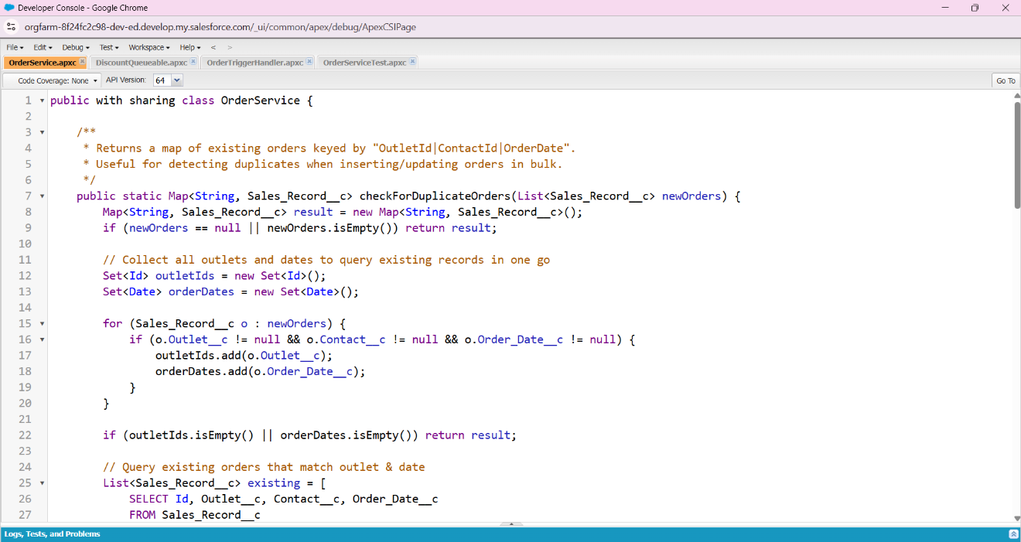

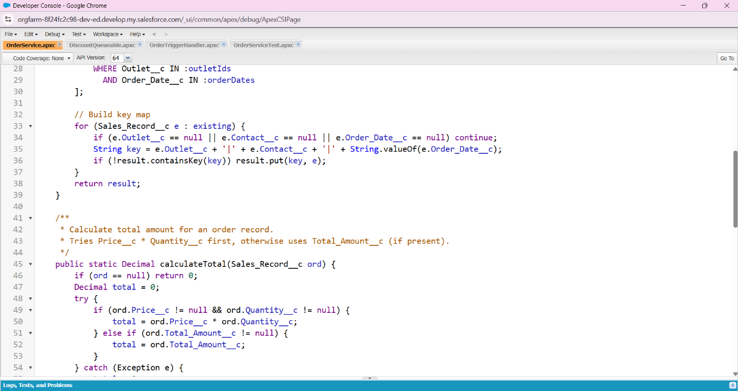

# 2. DiscountQueueable.cls

public class DiscountQueueable implements Queueable {  
 private Set<Id> orderIds;  
  
 public DiscountQueueable(Set<Id> orderIds) {  
 this.orderIds = orderIds;  
 }  
  
 public void execute(QueueableContext context) {  
 List<Sales_Record__c> orders = [  
 SELECT Id, Total_Amount__c  
 FROM Sales_Record__c  
 WHERE Id IN :orderIds  
 ];  
  
 for (Sales_Record__c ord : orders) {  
 if (ord.Total_Amount__c != null && ord.Total_Amount__c > 500) {  
 ord.Total_Amount__c = ord.Total_Amount__c * 0.9;  
 }  
 }  
 if (!orders.isEmpty()) {  
 update orders;  
 }  
 }  
}

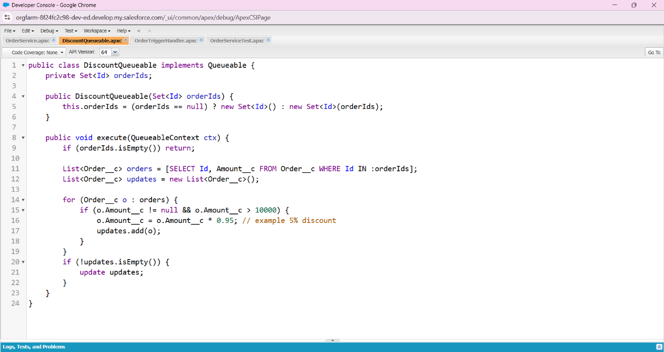

# 3. OrderTriggerHandler.cls

public with sharing class OrderTriggerHandler {  
 public static void beforeInsert(List<Sales_Record__c> newOrders) {  
 for (Sales_Record__c ord : newOrders) {  
 OrderService.checkDateConflicts(ord);  
 ord.Total_Amount__c = OrderService.calculateTotal(ord);  
 }  
 }  
  
 public static void beforeUpdate(List<Sales_Record__c> updatedOrders) {  
 for (Sales_Record__c ord : updatedOrders) {  
 OrderService.checkDateConflicts(ord);  
 ord.Total_Amount__c = OrderService.calculateTotal(ord);  
 }  
 }  
  
 public static void afterInsert(List<Sales_Record__c> newOrders) {  
 Set<Id> orderIds = new Set<Id>();  
 for (Sales_Record__c ord : newOrders) {  
 if (ord.Id != null) orderIds.add(ord.Id);  
 }  
 if (!orderIds.isEmpty()) {  
 OrderService.enqueueDiscountCalculation(orderIds);  
 }  
 }  
}

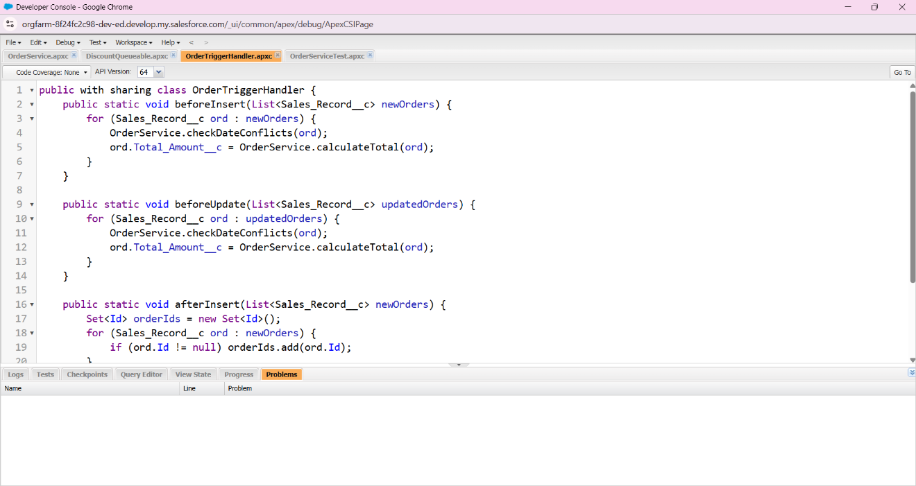

# 4. OrderTrigger.trigger

trigger OrderTrigger on Sales_Record__c (before insert, before update, after insert) {  
 if (Trigger.isBefore) {  
 if (Trigger.isInsert) {  
 OrderTriggerHandler.beforeInsert(Trigger.new);  
 } else if (Trigger.isUpdate) {  
 OrderTriggerHandler.beforeUpdate(Trigger.new);  
 }  
 } else if (Trigger.isAfter) {  
 if (Trigger.isInsert) {  
 OrderTriggerHandler.afterInsert(Trigger.new);  
 }  
 }  
}

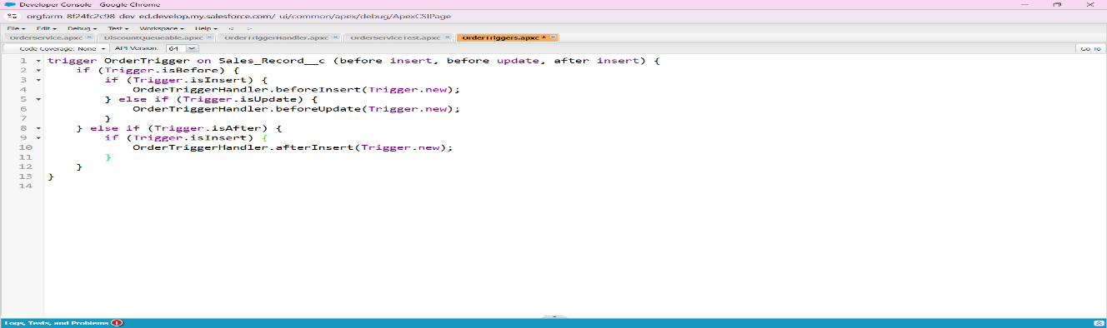

# 5. OrderServiceTest.cls

@isTest  
private class OrderServiceTest {  
  
 @isTest  
 static void testCalculateTotal() {  
 Outlet__c outlet = new Outlet__c(Name='Test Outlet');  
 insert outlet;  
  
 Sales_Record__c ord = new Sales_Record__c();  
 ord.Price__c = 100;  
 ord.Quantity__c = 2;  
 ord.Contact__c = 12345;  
 ord.Order_Date__c = Date.today();  
 ord.Outlet__c = outlet.Id;  
 insert ord;  
  
 Test.startTest();  
 Decimal total = OrderService.calculateTotal(ord);  
 Test.stopTest();  
  
 System.assertEquals(200, total);  
 }  
  
 @isTest  
 static void testCheckForDuplicateOrders() {  
 Outlet__c outlet = new Outlet__c(Name='Duplicate Outlet');  
 insert outlet;  
  
 Sales_Record__c ord1 = new Sales_Record__c(  
 Price__c = 50,  
 Quantity__c = 1,  
 Contact__c = 12345,  
 Order_Date__c = Date.today(),  
 Outlet__c = outlet.Id  
 );  
 insert ord1;  
  
 Sales_Record__c ord2 = new Sales_Record__c(  
 Price__c = 50,  
 Quantity__c = 1,  
 Contact__c = 12345,  
 Order_Date__c = Date.today(),  
 Outlet__c = outlet.Id  
 );  
  
 List<Sales_Record__c> newOrders = new List<Sales_Record__c>{ord2};  
  
 Test.startTest();  
 Map<String, Sales_Record__c> dupes = OrderService.checkForDuplicateOrders(newOrders);  
 Test.stopTest();  
  
 System.assert(!dupes.isEmpty(), 'Duplicate should be found');  
 }  
  
 @isTest  
 static void testCheckDateConflicts() {  
 Outlet__c outlet = new Outlet__c(Name='Conflict Outlet');  
 insert outlet;  
  
 Sales_Record__c existing = new Sales_Record__c(  
 Price__c = 10,  
 Quantity__c = 1,  
 Contact__c = 67890,  
 Order_Date__c = Date.today(),  
 Outlet__c = outlet.Id,  
 Start_Date__c = Date.today(),  
 End_Date__c = Date.today().addDays(5)  
 );  
 insert existing;  
  
 Sales_Record__c newOrder = new Sales_Record__c(  
 Price__c = 20,  
 Quantity__c = 2,  
 Contact__c = 67890,  
 Order_Date__c = Date.today(),  
 Outlet__c = outlet.Id,  
 Start_Date__c = Date.today().addDays(2),  
 End_Date__c = Date.today().addDays(7)  
 );  
  
 Test.startTest();  
 OrderService.checkDateConflicts(newOrder);  
 Test.stopTest();  
  
 System.assert(newOrder.getErrors().size() > 0, 'Conflict should have been detected');  
 }  
  
 @isTest  
 static void testEnqueueDiscountCalculation() {  
 Outlet__c outlet = new Outlet__c(Name='Discount Outlet');  
 insert outlet;  
  
 Sales_Record__c ord = new Sales_Record__c(  
 Price__c = 100,  
 Quantity__c = 1,  
 Contact__c = 99999,  
 Order_Date__c = Date.today(),  
 Outlet__c = outlet.Id,  
 Start_Date__c = Date.today(),  
 End_Date__c = Date.today().addDays(1),  
 Total_Amount__c = 600  
 );  
 insert ord;  
  
 Test.startTest();  
 OrderService.enqueueDiscountCalculation(new Set<Id>{ord.Id});  
 Test.stopTest();  
  
 System.assert(true, 'Queueable job should have been enqueued');  
 }  
}

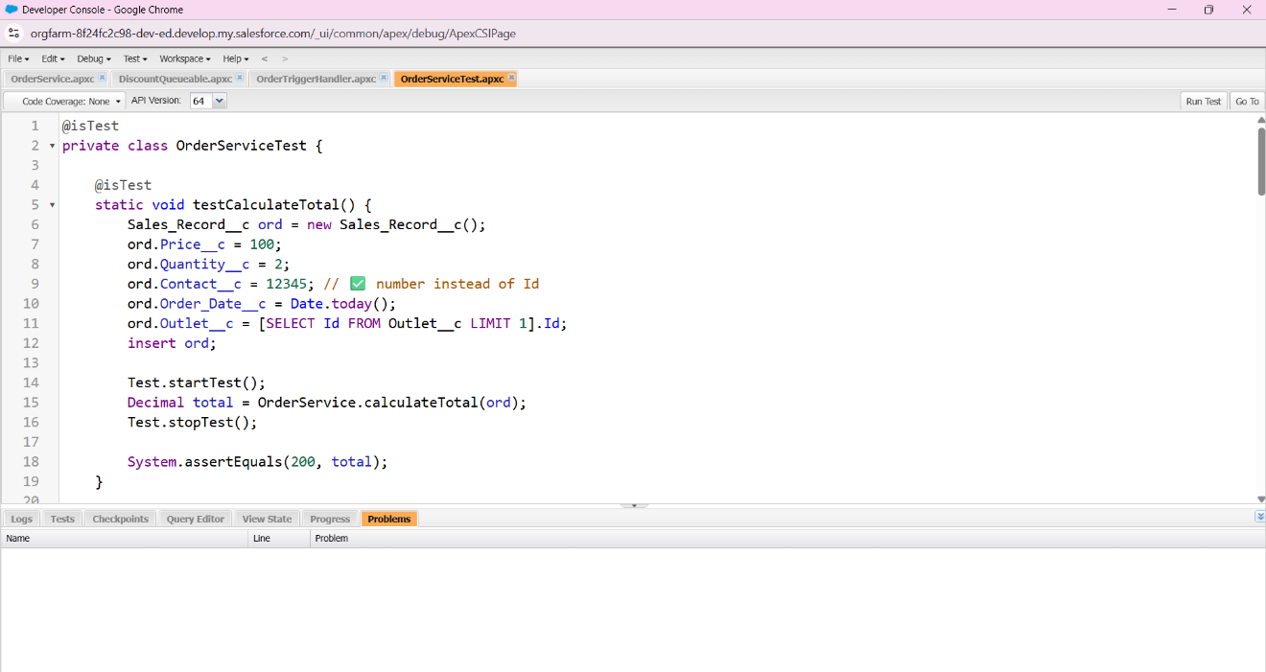

### 1. **OrderService.cls**

This is the main **service class** that holds reusable business logic for Sales Records, like calculating totals, checking duplicates, validating date conflicts, and enqueuing async jobs.

### 2. **DiscountQueueable.cls**

This is a **Queueable Apex class** that runs discount calculations asynchronously in the background, ensuring bulk operations don’t slow down user transactions.

### 3. **OrderTriggerHandler.cls**

This is the **trigger handler** class that cleanly organizes logic (before insert, before update, etc.), following the **Trigger Design Pattern** so your trigger remains simple and maintainable.

### 4. **OrderTrigger.trigger**

This is the **actual trigger** on the Sales_Record__c object that routes events (insert/update/delete) into the OrderTriggerHandler, making sure your business rules execute automatically when records change.

### 5. **OrderServiceTest.cls**

This is the **unit test class** that validates the logic in OrderService, ensuring correctness, preventing regressions, and providing >75% code coverage to meet Salesforce deployment requirements.

# Phase 6: User Interface Development (Franchies Management CRM)

This document contains the required steps and sample code for Phase 6 of the project. The goal is to build a user-friendly interface using Lightning App Builder, Tabs, Record Pages, and Lightning Web Components (LWC).

## 1. Lightning App Builder

Create a new Lightning App called 'Car Rental CRM'. Add navigation items (tabs) for Cars (Outlet__c) and Bookings (Sales_Record__c).

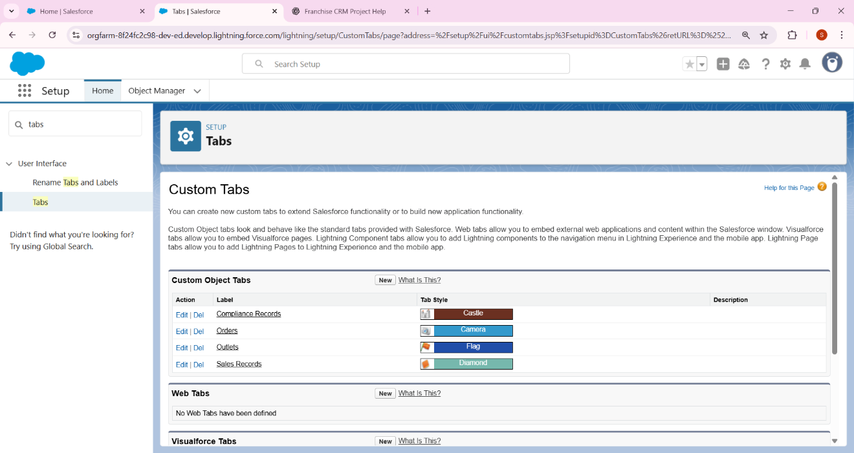

How I create Lightning App Builder

1. Setup → Quick Find → App Manager.
2. Click New Lightning App (top-right).
3. Step 1 — App Details & Branding
   * App Name: Car Rental CRM
   * (Optional) add Description, App Logo/Colors.
   * Click Next.
4. Step 2 — Navigation Items
   * From Available Items find and select:
     + Outlets (your Outlet tab) — or the label you created.
     + Sales Records (your Sales_Record__/Bookings tab).
   * Use the Add (→) button so they appear in Selected Items in the order you want them to appear in the app navigation bar.
   * (Optional) add other useful items like Home, Reports, Dashboards.
   * Click Next.
5. Step 3 — Utility Bar (optional)
   * You can add a Utility Item such as Quick Action → “New Booking” later. For now click Next (or add it here if you want).
6. Step 4 — Assign to Profiles
   * Choose which profiles should have this app (System Administrator must be selected so you can use it).
   * Click Save & Finish.

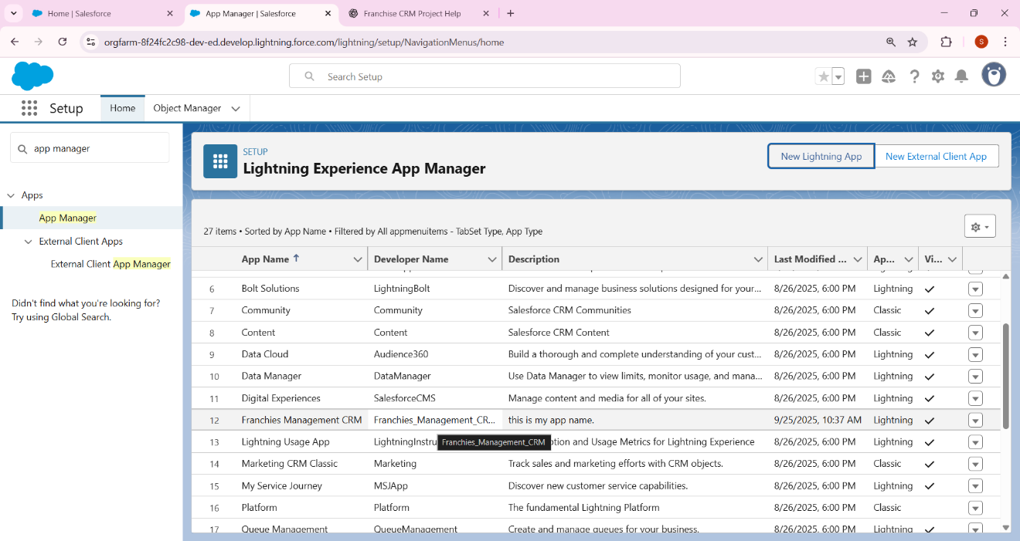

## 2**. Record Pages**

Open Outlet__c record page in Lightning App Builder. Add Related List – Sales Records so that related bookings are visible.

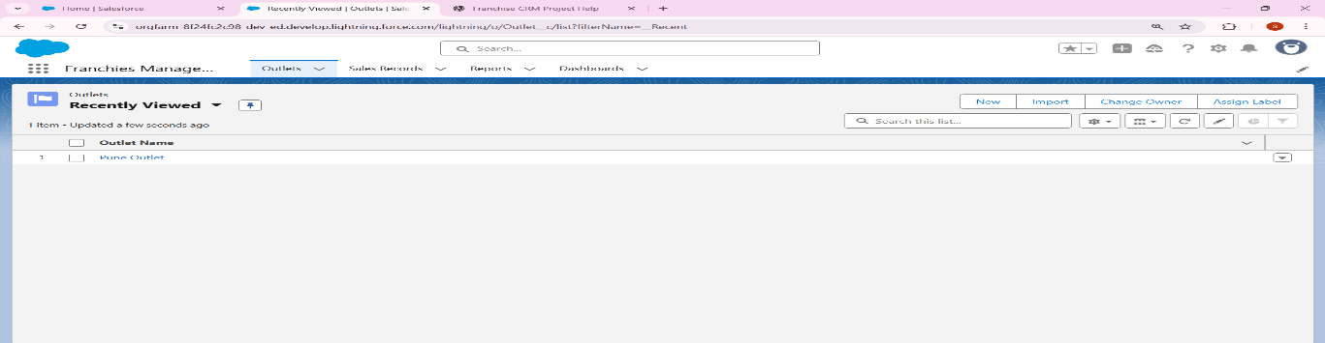

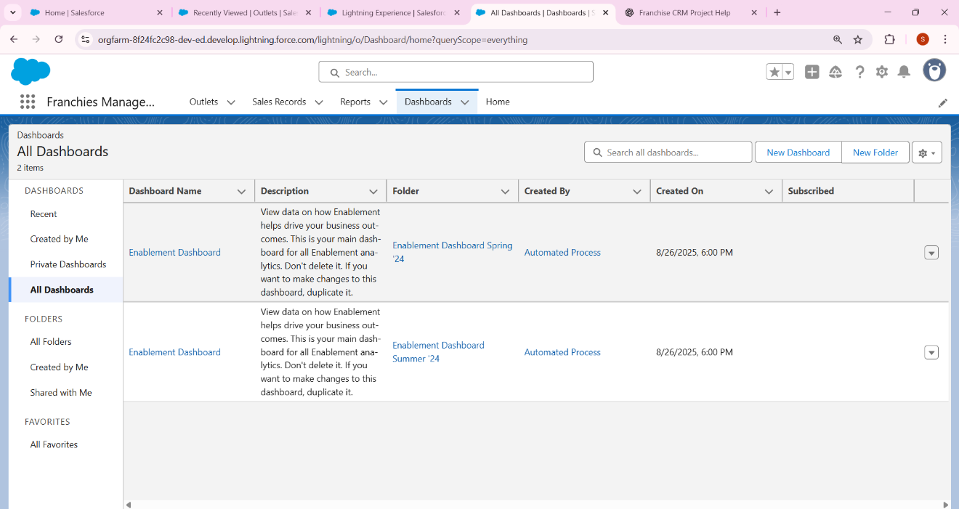

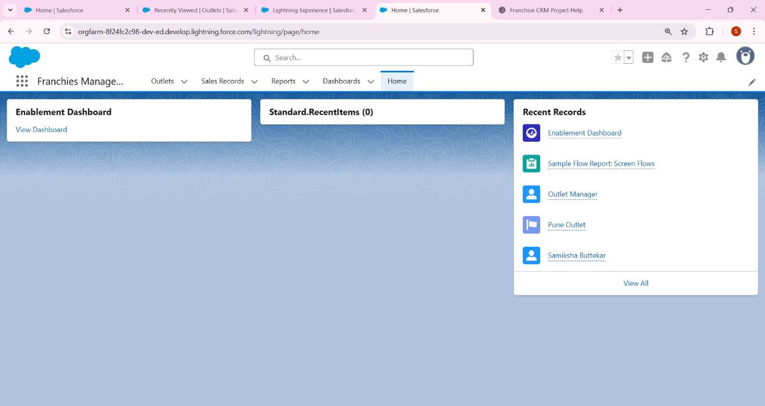

## Tabs

Add custom tabs for Outlet__c (Franchies) and Sales_Record__c (Bookings).

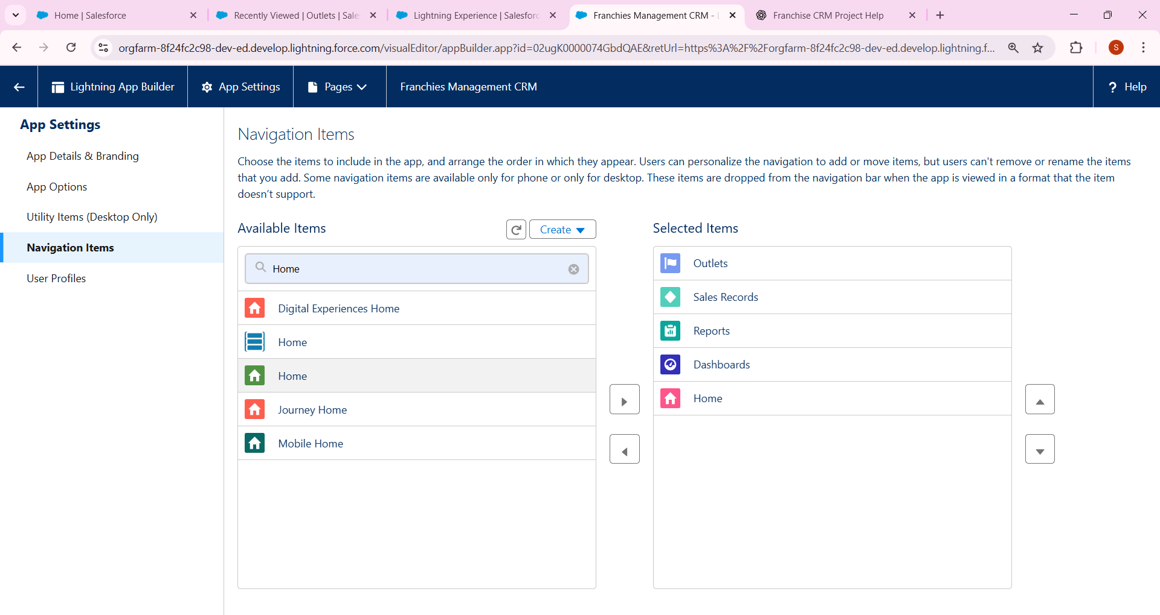

## **4. Home Page Layout (Dashboard)**

Edit Home Page in App Builder. Add a Report or Dashboard Component showing fleet utilization (Active vs Non-Compliant Outlets or Bookings by Status).

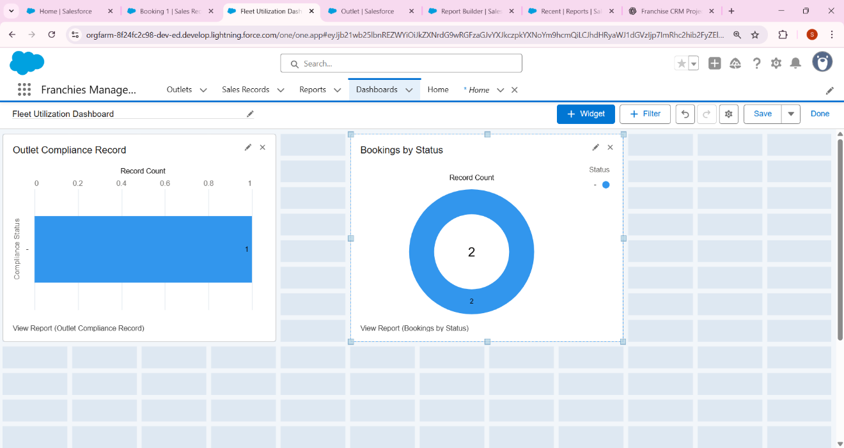

## **5. Utility Bar (Quick Action)**

Add a Utility Bar item → 'New Booking' quick action to allow users to create bookings from anywhere.

## **6. LWC – Search Franchies by Date**

Create an LWC named carSearch with a search form (Start Date, End Date), search button, and a datatable to show available cars (Outlets).

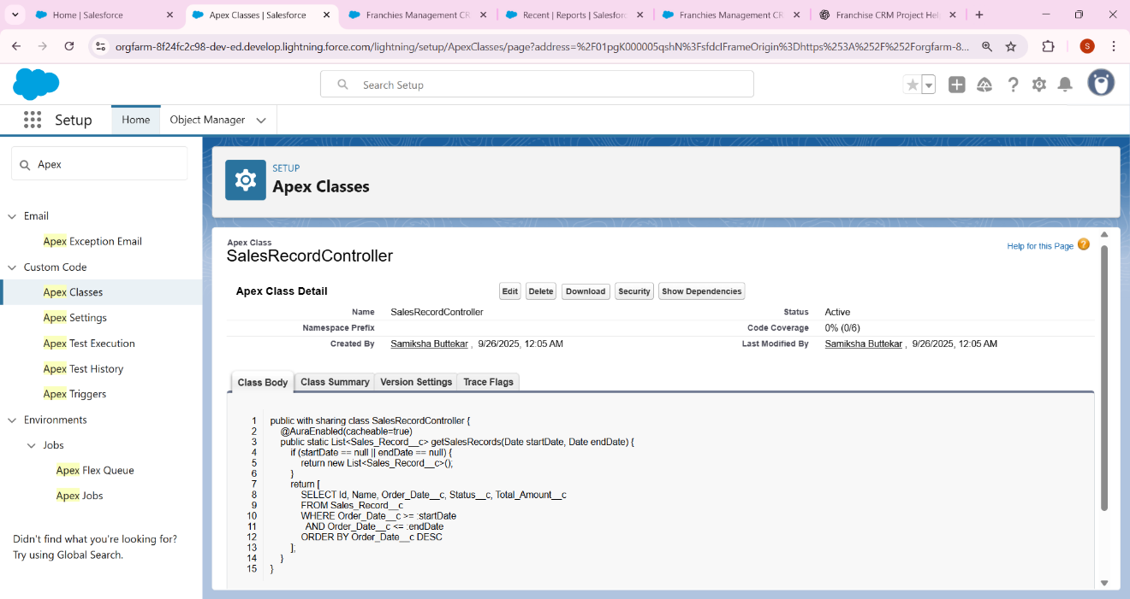

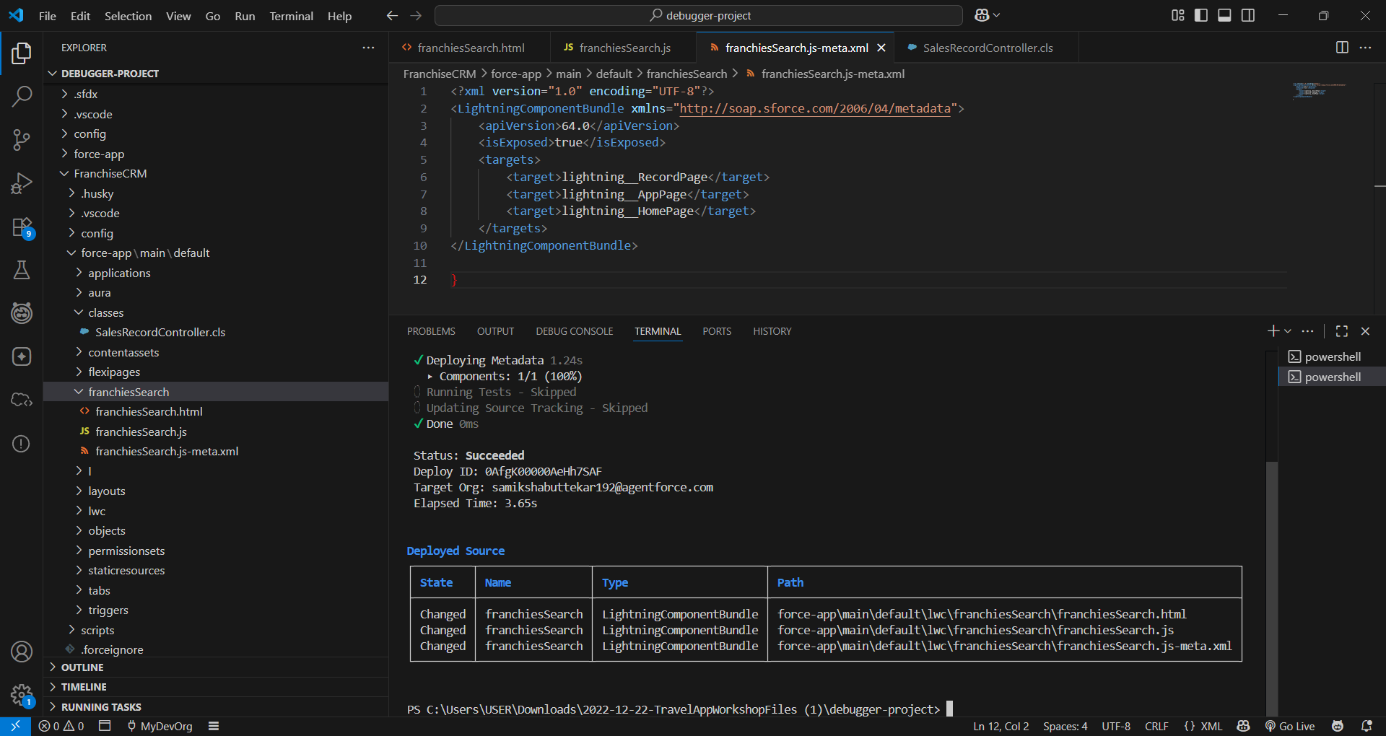

## 7. Apex with LWC (Imperative Call)

Create an Apex method to search available cars based on date range. Call this method imperatively from LWC when the user clicks search.

## 8. Events in LWC

Child component = search form. Parent component = results table. Child sends search event to Parent, which queries cars and displays results.

## 9. Wire Adapters

Use @wire to fetch list of available cars automatically when the component loads.

## 10. Imperative Apex Call (Booking)

When user clicks 'Book Now' in the datatable, call Apex imperatively to create a booking record.

## 11. Navigation Service

Use NavigationMixin in LWC to redirect the user to the newly created Sales_Record__c record page after booking.

## Sample Apex Code

public with sharing class CarSearchController {  
 @AuraEnabled(cacheable=true)  
 public static List<Outlet__c> searchAvailableCars(Date startDate, Date endDate) {  
 return [  
 SELECT Id, Name, Status__c   
 FROM Outlet__c   
 WHERE Status__c = 'Active'  
 ];  
 }  
  
 @AuraEnabled  
 public static Id createBooking(Id outletId, Date startDate, Date endDate) {  
 Sales_Record__c booking = new Sales_Record__c(  
 Outlet__c = outletId,  
 Start_Date__c = startDate,  
 End_Date__c = endDate,  
 Status__c = 'Active'  
 );  
 insert booking;  
 return booking.Id;  
 }  
}

## Sample LWC Code

// carSearch.js  
import { LightningElement, track } from 'lwc';  
import searchAvailableCars from '@salesforce/apex/CarSearchController.searchAvailableCars';  
import createBooking from '@salesforce/apex/CarSearchController.createBooking';  
import { NavigationMixin } from 'lightning/navigation';  
  
export default class CarSearch extends NavigationMixin(LightningElement) {  
 @track startDate;  
 @track endDate;  
 @track cars = [];  
  
 handleDateChange(event) {  
 if (event.target.name === 'startDate') this.startDate = event.target.value;  
 if (event.target.name === 'endDate') this.endDate = event.target.value;  
 }  
  
 handleSearch() {  
 searchAvailableCars({ startDate: this.startDate, endDate: this.endDate })  
 .then(result => { this.cars = result; })  
 .catch(error => { console.error(error); });  
 }  
  
 handleBook(event) {  
 const outletId = event.target.dataset.id;  
 createBooking({ outletId: outletId, startDate: this.startDate, endDate: this.endDate })  
 .then(recordId => {  
 this[NavigationMixin.Navigate]({  
 type: 'standard__recordPage',  
 attributes: {  
 recordId: recordId,  
 objectApiName: 'Sales_Record__c',  
 actionName: 'view'  
 }  
 });  
 })  
 .catch(error => { console.error(error); });  
 }  
}

Bottom of Form

Phase 7: Integration & External Access

1. **Named Credentials**

* Setup → Named Credentials → create one for your Insurance/Franchise API (URL + Auth).
* Example: FranchiseInsuranceAPI.

• **Create External Credential**

* Setup → External Credentials → **New**
* **Label:** Franchise Insurance External Credential
* **Name:** FranchiseInsuranceExtCred
* **Authentication Protocol:** **Basic Authentication**
* Save

• **Add a Principal (username + password)**

* After saving → click **New Principal**
* Principal Name: FranchiseAPIUser
* Username: apiuser (your API username)
* Password: apipass123 (your API password or key)
* Save

• **Create Named Credential**

* Setup → Named Credentials → **New**
* Label: **Franchise Insurance API**
* Name: FranchiseInsuranceAPI
* URL: https://api.insurancecompany.com/verify
* Enabled for Callouts
* **External Credential:** Select FranchiseInsuranceExtCred
* Save

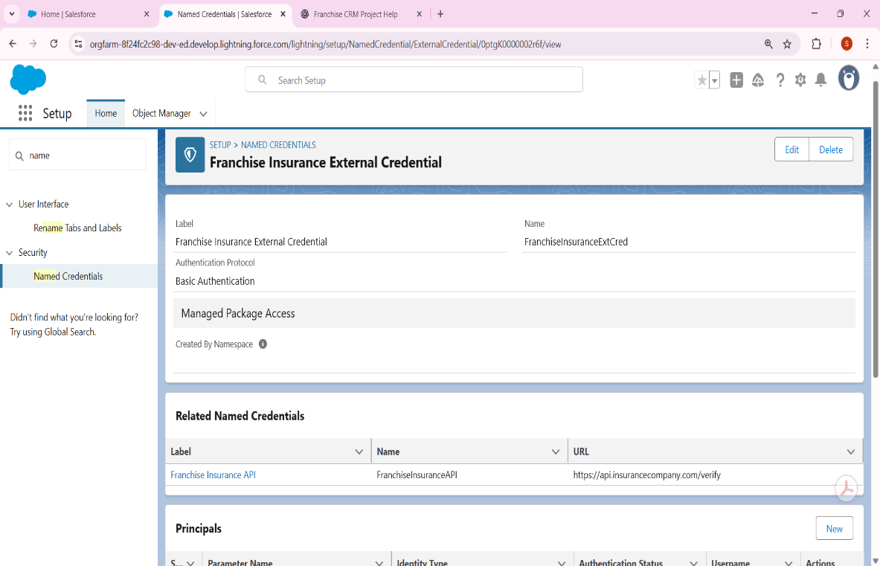

* 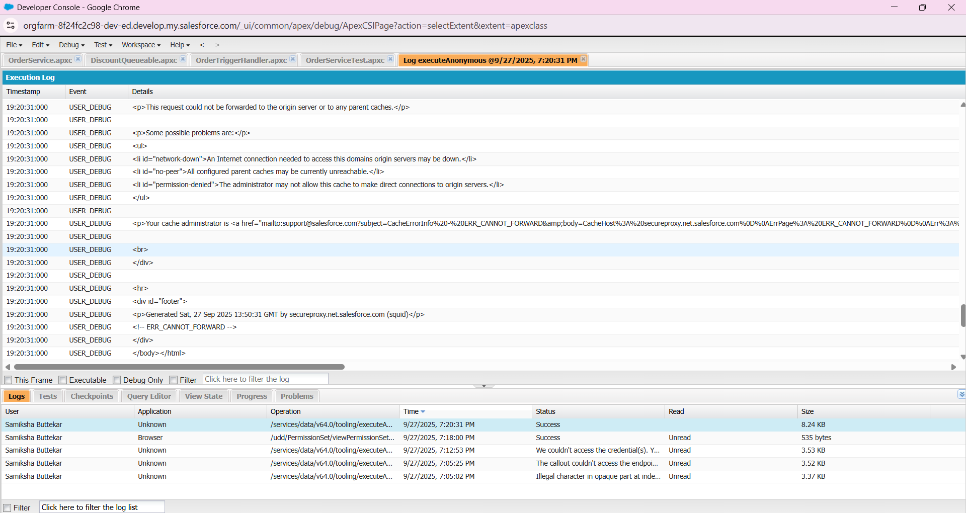

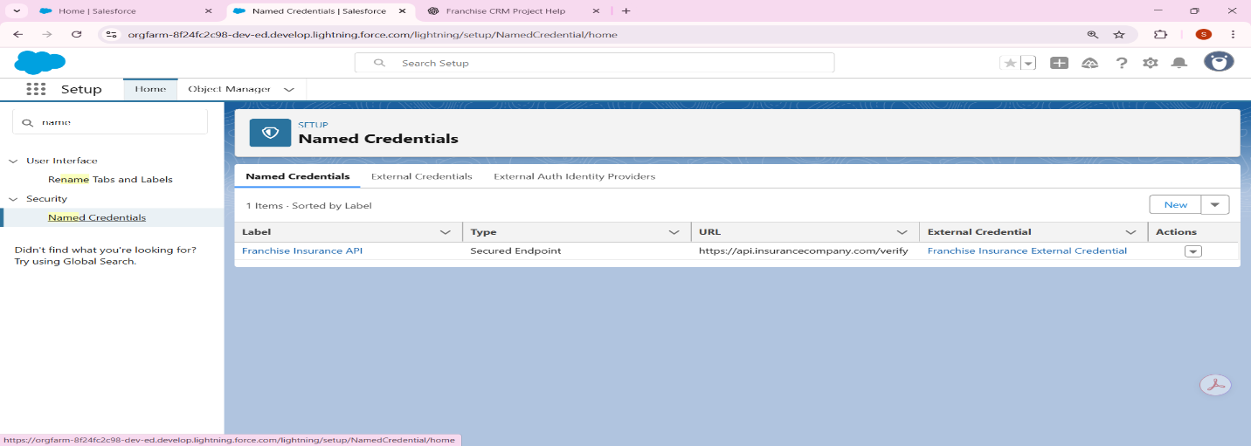

1. **External Services (Theoretical Step)**

In a real Franchise Management CRM, we might need to connect Salesforce with external services, such as insurance verification APIs provided by third-party companies.

* Normally, the insurance provider would share an OpenAPI/Swagger schema file(JSON/YAML**)** that describes their API (endpoints, request/response structure, authentication).
* In Salesforce, we would go to:  
  Setup → External Services → Register  
  and upload the schema or provide its URL.
* Salesforce automatically generates Apex Actions that can be invoked from Flows,Processes, or Apex code.
* For example:
  + When a franchise booking is created → Salesforce could send customer details to the Insurance API.
  + The API would respond with **Verification Status (Approved/Rejected)**.
  + Salesforce Flow would update the Booking record accordingly.

⚠️ **Note:** Since this project is for learning/demo and no real insurance API is provided, this step remains **theoretical**. If in the future an API is available, this setup will allow seamless integration.

1. **Web Services (REST Callouts)**

Create Apex class → make REST callout to insurance system.

1 Create name crendential

1. Go to **Setup → Named Credentials**.
2. Click **New Named Credential**.
   * **Label**: JSONPlaceholder
   * **Name**: JSONPlaceholder
   * **URL**: https://jsonplaceholder.typicode.com
   * Authentication: **No Authentication**
3. Save.

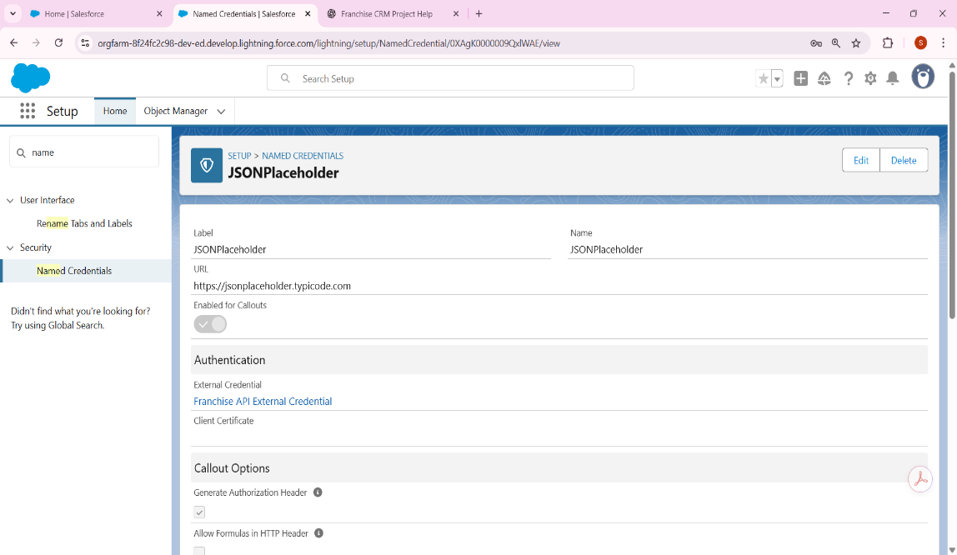

* 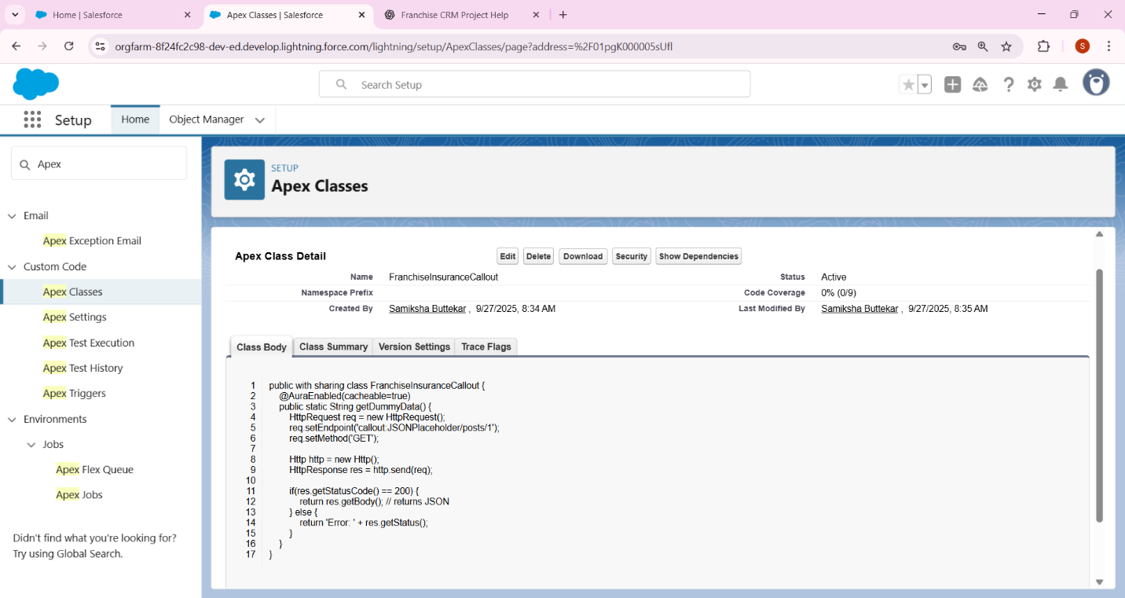
* **For a real production Franchise CRM** → Yes, it’s valuable if you need to validate franchise data (e.g., insurance, license, GST, etc.) in real time when a record is created.
* **For My project/demo** → It’s **optional.** We can either:
  + Do it **theoretical** (just describe how Salesforce can trigger a callout after a record is created).
  + Or do it **hands-on demo** with a fake API (like JSONPlaceholder) to prove the concept.

Since we already tested **Named Credentials & REST callouts**, this step is just connecting them to a **trigger event.**

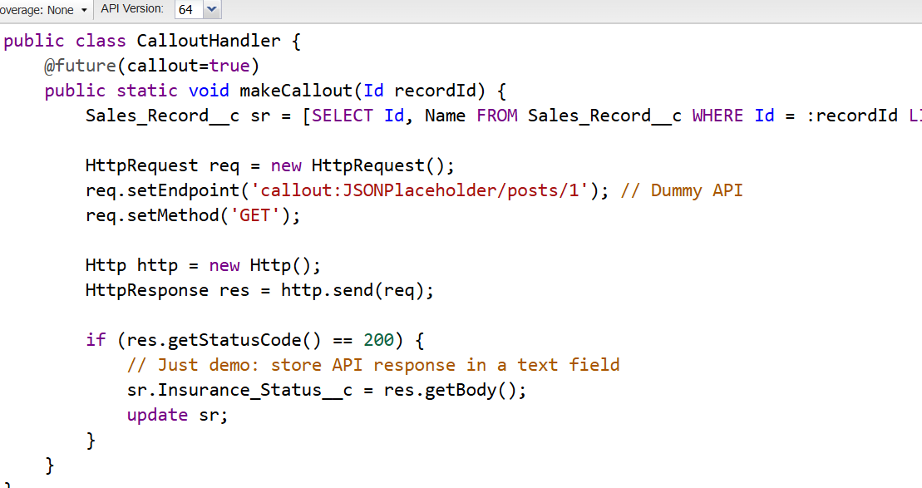

**4 Platform Events (Franchise_Breakdown__e)**

1. Create a Platform Event
2. In Salesforce Setup → search **Platform Events** → Click **New Platform Event**.
3. Fill the details:
   * **Label:** Franchise Breakdown
   * **Plural Label:** Franchise Breakdowns
   * **API Name:** Franchise_Breakdown__e (auto-generated**).**
   * **Publish Behavior:** Publish Immediately (default).
4. Save.
5. 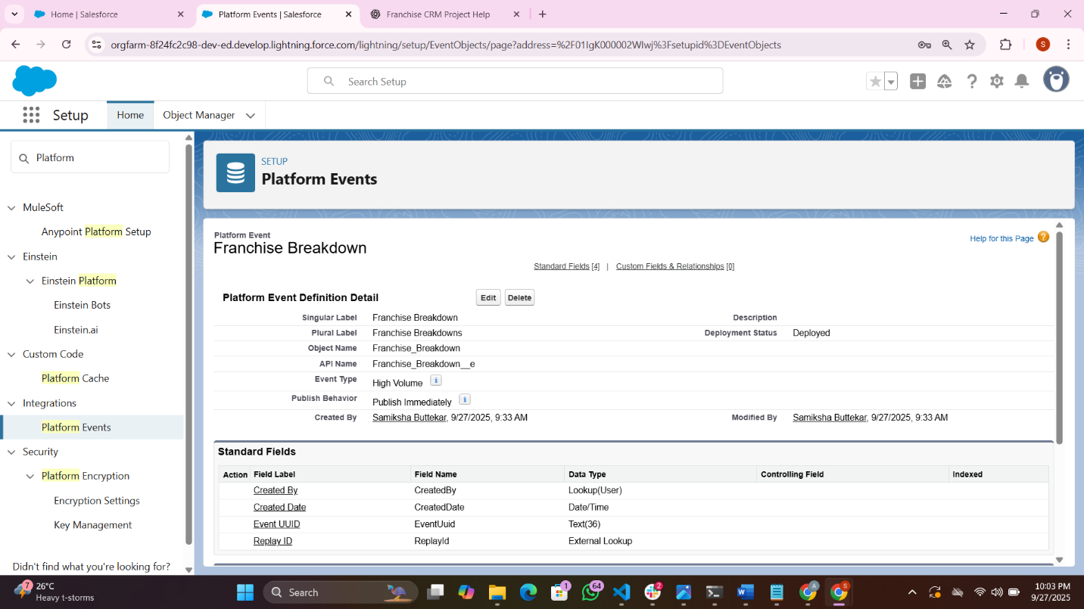

2 Add fields

After saving, add a couple of fields that describe the breakdown:

* + **FranchiseId__c** (Text, 18 chars) → to track the franchise record.
  + **IssueType__c** (Picklist: ["Car Breakdown", "System Issue", "Insurance"])
  + **Description__c (**Long Text Area, 255).

This way, when an event is published, it carries meaningful info

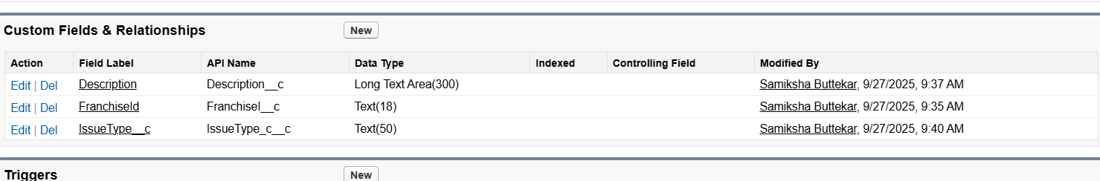

🚀 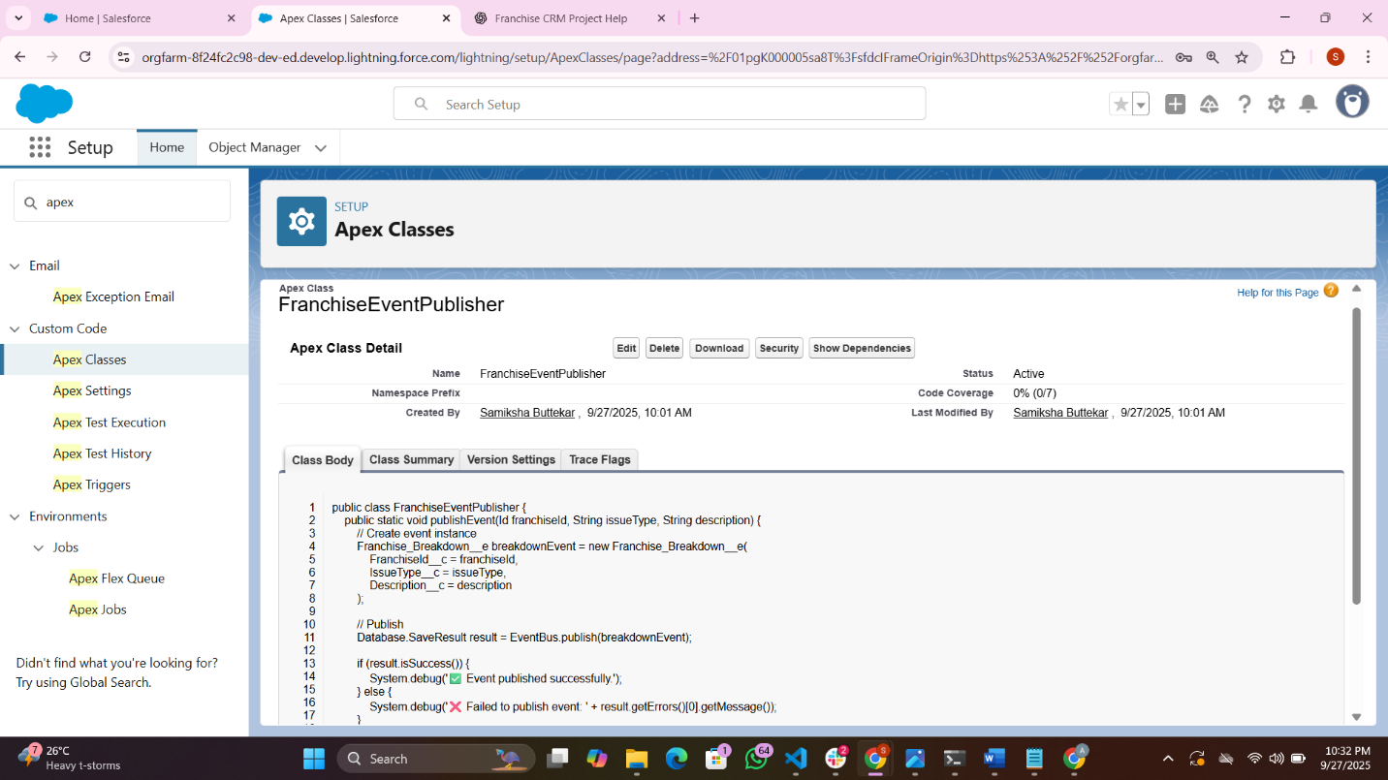

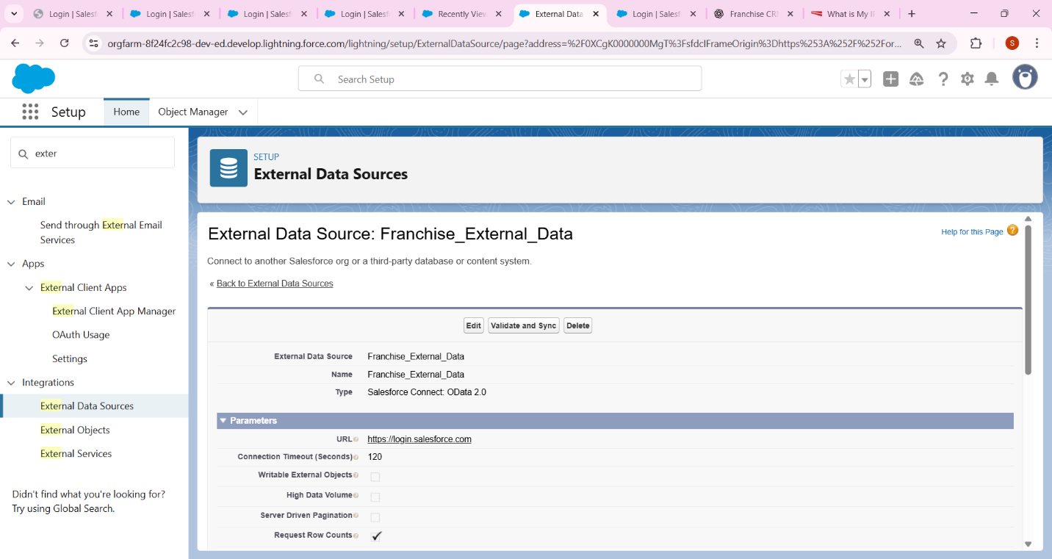

**6. API Limits**

Use Case In My Project

* **API Requests, Last 24 Hours = 487 (3% of 15,000 max)**  
  This means in the last 24 hours, Salesforce has made **487 API requests** (including your callouts, background jobs, and any integration).  
  You’re safe because it’s well under the daily **15,000 limit** for Developer Edition.

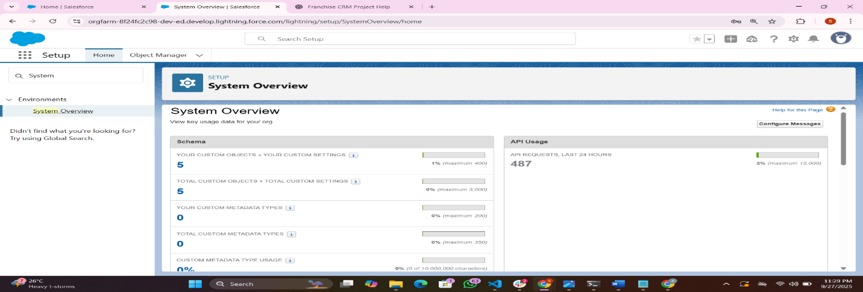

### 7 OAuth & Authentication (Franchise Portal)

### Use Case for my project this step is therotical

* Imagine your CRM has a **Franchise Partner Portal** where franchise owners log in to check reports, submit requests, or view sales data.
* Instead of giving them Salesforce usernames/passwords, you allow them to **log in with Google, LinkedIn, or company SSO.**
* Salesforce uses **OAuth 2.0** to authenticate them securely.
* Example flow:
  1. Franchise owner clicks **“Login with Google”.**
  2. Salesforce redirects them to Google’s OAuth service.
  3. If Google verifies them, Salesforce grants access to the portal.
  4. Salesforce applies correct permissions (only see their own franchise data).

This improves **security** and gives franchise partners a smooth login experience.

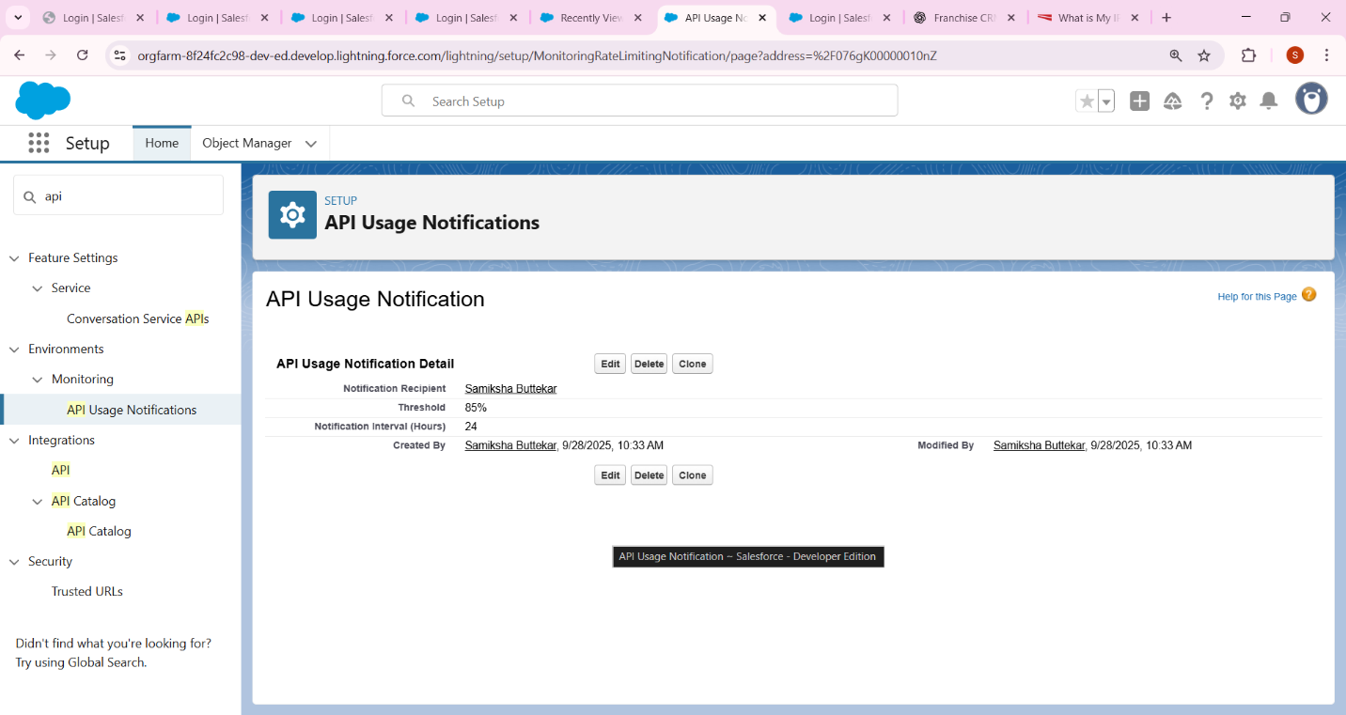

### 8 Remote Site Setting

### Use Case in Your Franchise Management CRM

* When a **franchise applies** or **sales record is created**, your system may need to **verify insurance** with an external provider’s API.
* Remote Site Settings allow Salesforce to “trust” and call that API.
* In your demo → you’re using JSONPlaceholder (free fake API) to simulate this.

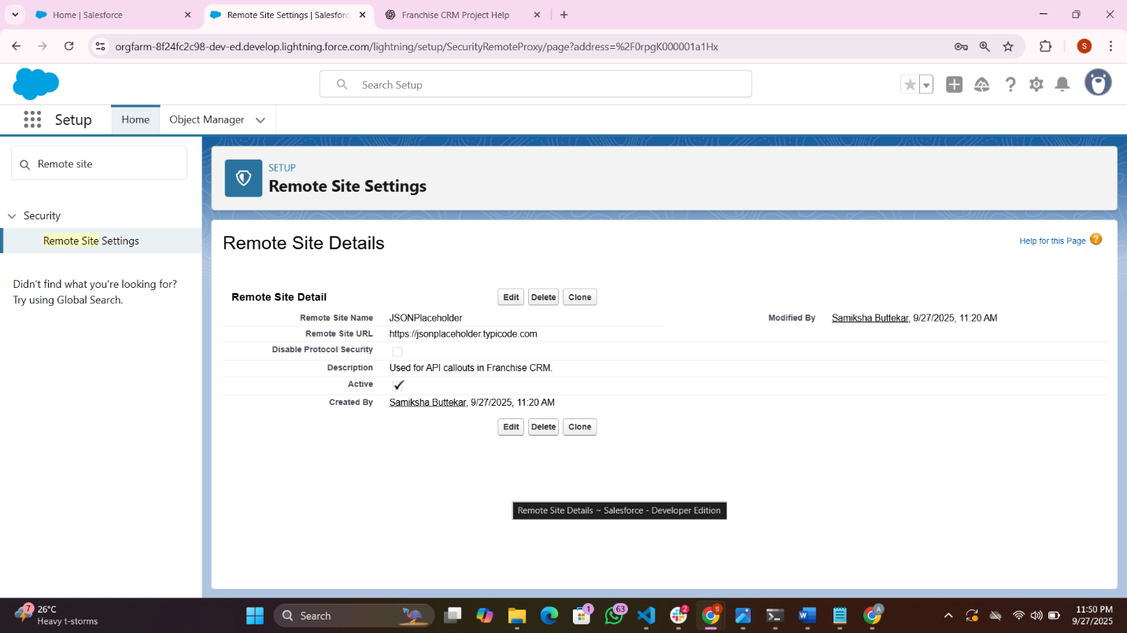

Phase 8: Data Management & Deployment

### 1 Data Import Wizard

**1 Since you’re in Setup, do this:**

1. In the **Quick Find (search bar on the left)**, type **“Data Import Wizard”.**
2. Click on **Data Import Wizard** under **Data Management**.
3. On the Data Import Wizard 1page, scroll down to the **Custom Objects** section.
4. You’ll see your **“Sales Record”** object listed there.
5. Click the **“Launch Wizard”** button under that object.

### 2: Choose Upload Options

Once the Data Import Wizard opens:

1. Click on **“Add New Records”** (since we’re importing new data).
2. Click **“CSV” → “Choose File”**.
3. Select your prepared **50-row CSV file** (the one we discussed earlier).
4. Click **Next**.

### 3: Field Mapping

Salesforce will now show you how your CSV columns match the Salesforce fields.

* Make sure each column is **mapped correctly:**
  + Name → Name
  + Order Date → Order Date
  + Amount → Amount
  + Status → Status
  + Description → Description

⚠️ If any field is showing as “Unmapped”:

* Click the dropdown beside it and choose the matching field manually.

Then click **Next**.

### 4: Review and Start Import

* Review the summary page (should say **50 records** ready to import).
* Click **Start Import**.

### 5: Check the Import Status

* Salesforce will show a confirmation message.
* Click **“View Import Status”** to track progress.
* Once done, go to the **Sales Record** tab in your app and you’ll see all 50 records imported

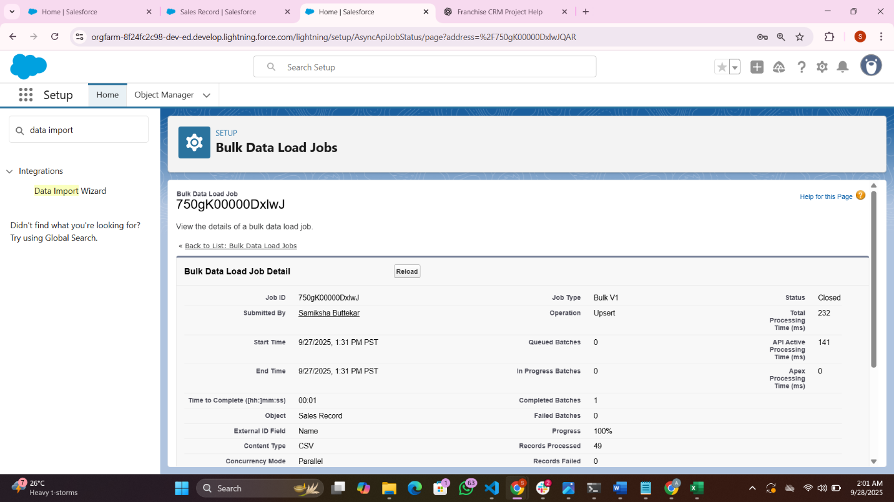

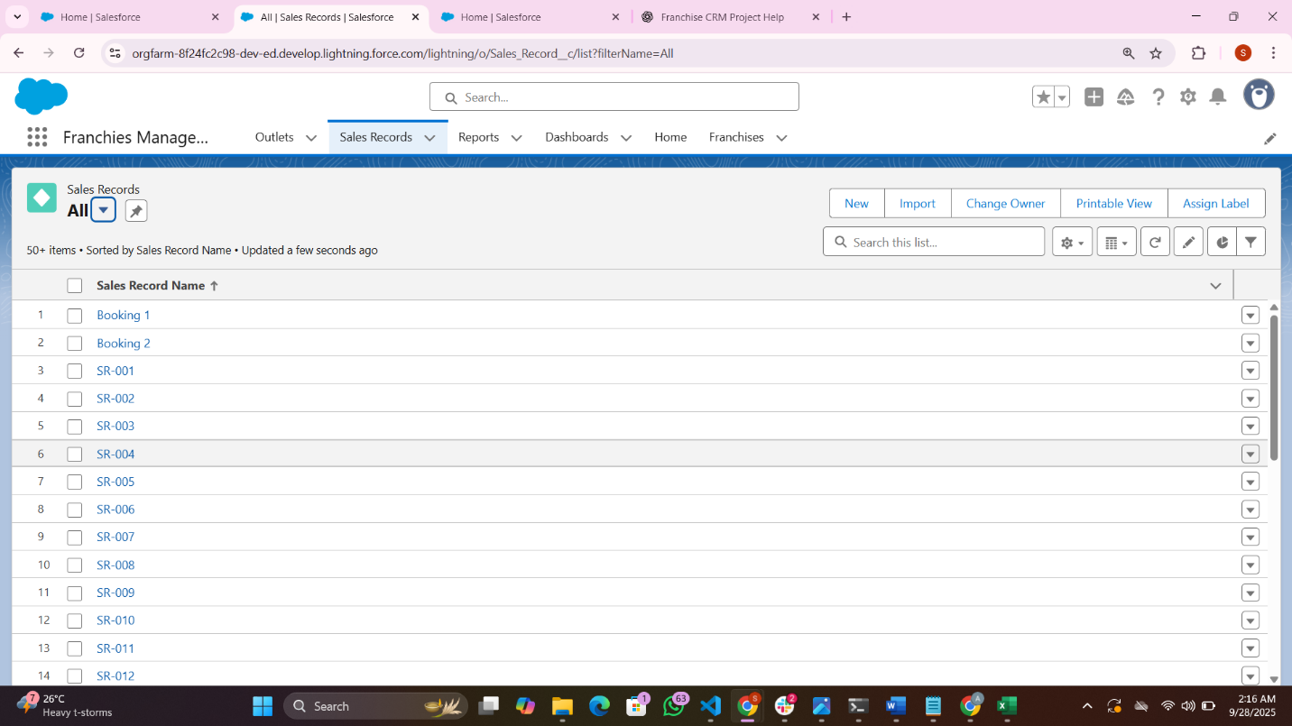

**2 Data Loader**

Import or update large datasets(bulk uploads)

1 open data loader: login

2 selected insert :choose CSV file for sales record

3 Mapped fields :started operation check success.

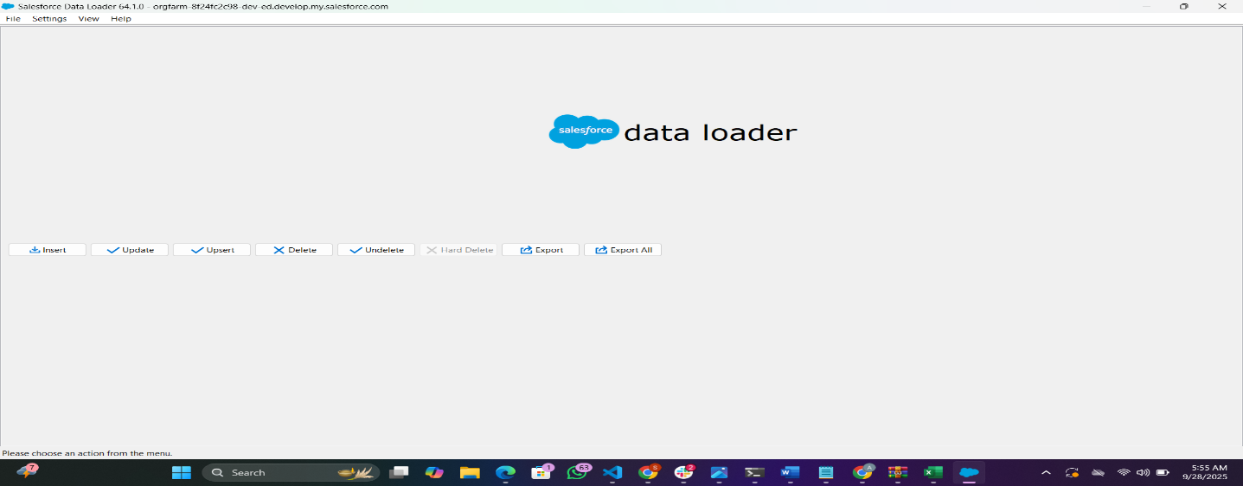

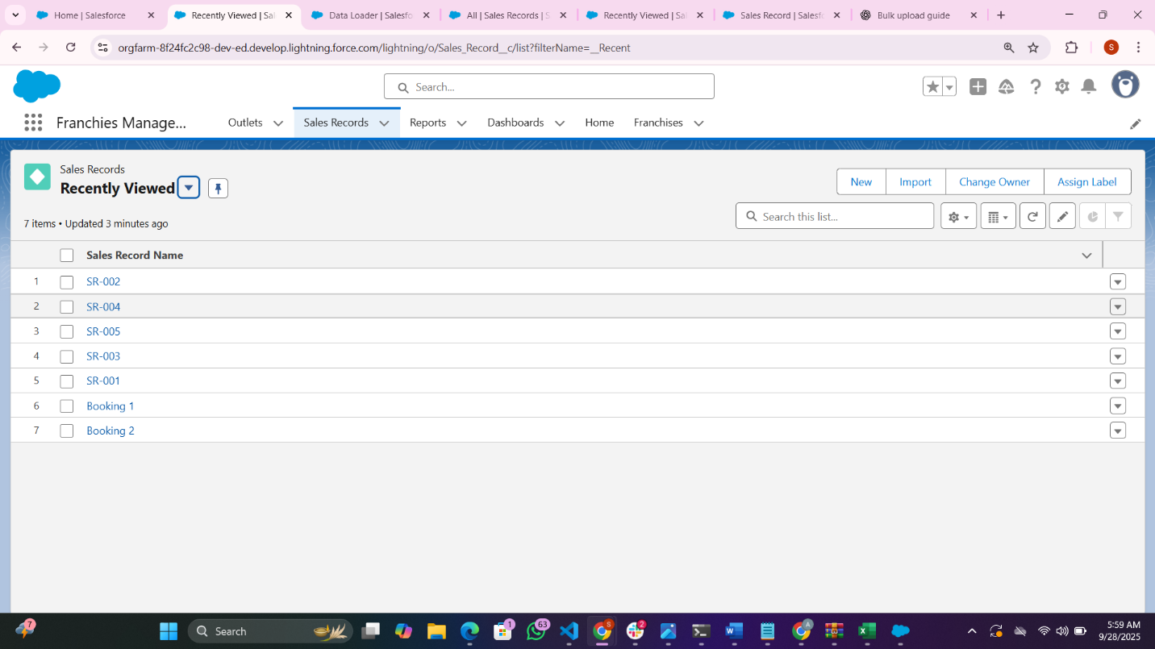

**3 Duplicate Rules**

1 Create Matching Rules

1. Go to **Setup** (gear icon → Setup).
2. In Quick Find, type **Matching Rules** → Click **New Rule.**
3. Select **Franchise__c** (your custom object).
4. Define matching criteria:
   * Add **Email__c** → Matching Method: **Exact**
   * Add **License_Number__c** → Matching Method: **Exact**
5. Click **Save** → then **Activate** the rule.

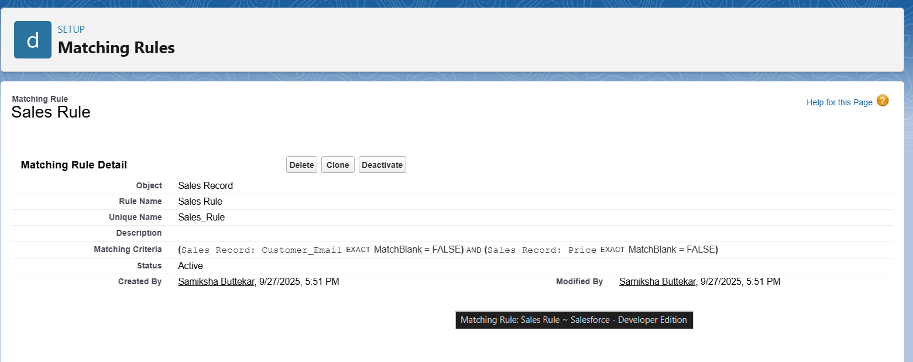

2 Create Duplicate Rules

1. In Setup, search for **Duplicate Rules** → Click **New Rule.**
2. Object = **Franchise__c.**
3. Give it a name: e.g., Prevent_Duplicate_Franchise.
4. Under **Matching Rule,** choose the one you created above.
5. **Action on Create** → Block
6. **Action on Edit →** Block (or Allow + Report, depending on business needs).
7. Alerts: Check **Alert** so the user sees a message like “Duplicate Franchise: Email/License already exists.”
8. Click **Save** → then **Activate** the Duplicate Rule.

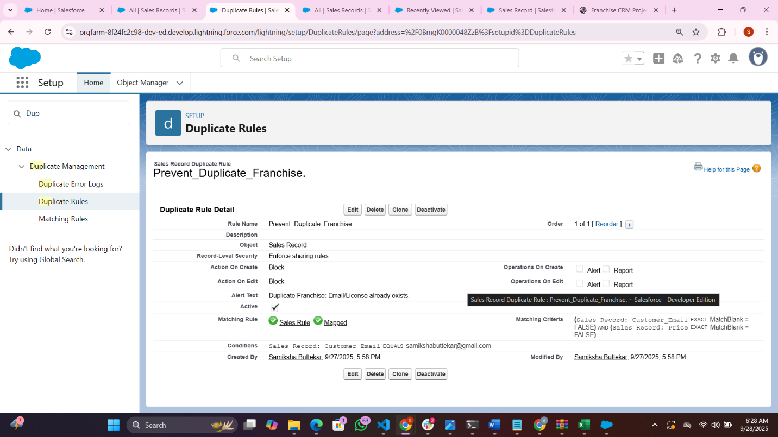

* **Use Case**

**With Duplicate Rule (Block ):**

* As soon as Salesforce detects an existing record with that **Email** or **License Number**, it will **stop the insert/update** and alert the user.

**4 Data Export & backup**

* + .Go to **Setup** in Salesforce.
  + In **Quick Find**, type **Data Export.**
  + Click **Data Export**.
  + You’ll see 2 options:
  + **Export Now** → One-time backup (manual).
  + **Schedule Export** → Weekly/monthly automatic backup.
  + Select the objects you want:
  + For your project, select at least:
    1. **Franchise__c**
    2. **Sales_Record__c / Booking__c**
  + You can also select **Attachments/Files** if needed.
  + Click **Start Export** (or schedule it).
  + Once ready, Salesforce sends you an email with a **download link** for the .zip file.

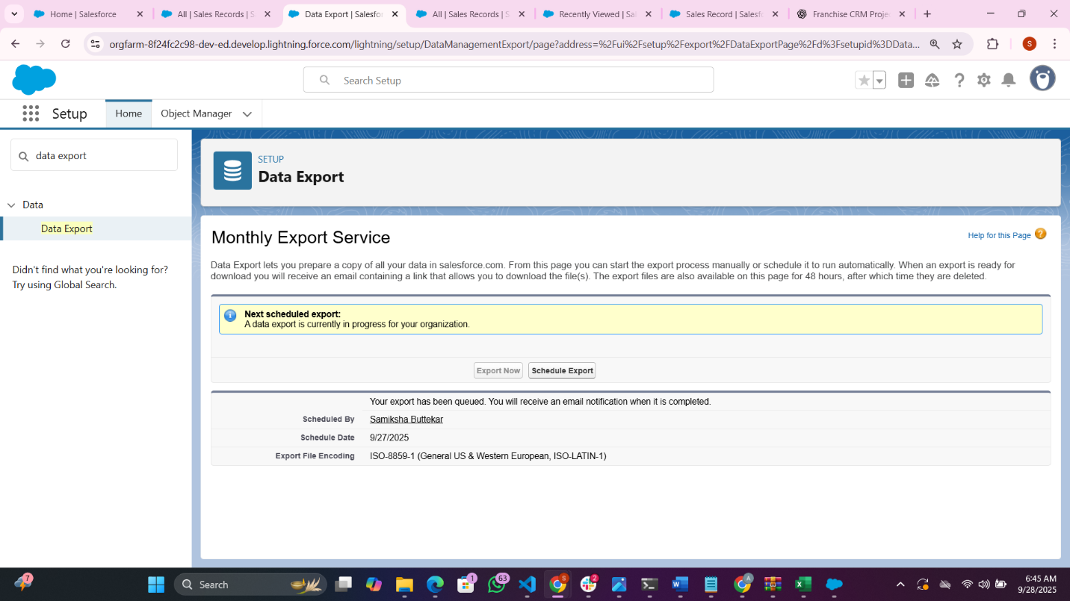

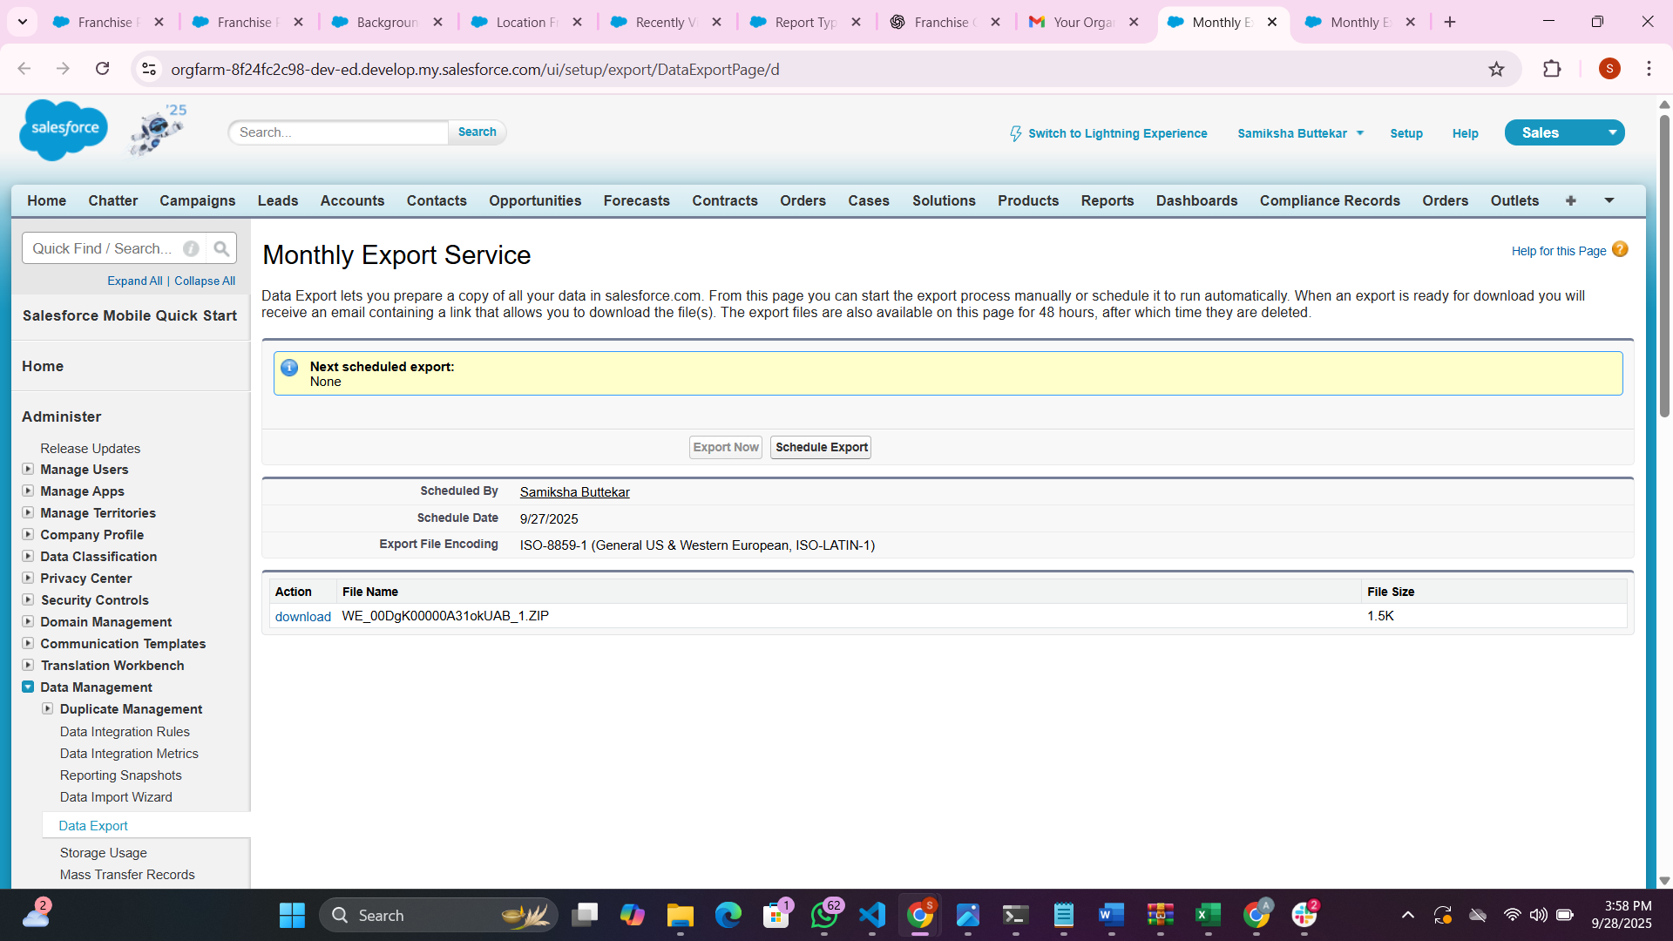

s

Use Case for this step is:

In your project, you are managing **Franchise records, Bookings, and Payments**.

* Imagine a situation where records are **accidentally deleted** (ex: via Data Loader or user mistake).
* Or if you need to keep a **backup copy** of all franchise and booking data for compliance.

The use case here is to ensure you always have a **safe copy of your Salesforce data** in case of corruption, accidental deletion, or migration

### ****5 Change Sets****

* **Not Available** in Developer Edition As We Are Using   
  Change Sets are only for **Sandbox → Production** deployment.
* ✅ So I can **skip this step** in your project.
* Use Case : In real-world enterprise setups, Change Sets are used to deploy customizations from Sandbox to Production. Since this project is built on a Developer Edition, deployments are directly done within the same org using VS Code (SFDX

**6 Unmanage and Manage Package**

* **Use Case (in My project):**
  + If my project is **just for my own org**, you don’t need packages.
  + If I want to **publish My Franchise CRM to other companies, I’d use a Managed Package**.

Our Franchise Management CRM is deployed internally using Change Sets. If published externally, a Managed Package would be required.

**7 ANT Use Case In My Project**

Useful if your project has large code/config deployments or if you want automated deployment from command line.

* Example: Deploy all Apex classes + flows + objects from one org to another with scripts.
* For enterprise-scale deployments, ANT Migration Tool could automate deployments, but for our project we use Change Sets.”

8 VS Code & SFDX (Salesforce CLI)

Phase 9: Reporting, Dashboards & Security Review

**1.Reports**

**Franchises by Location**

👉 Use Franchise__c object.

1. Go to **Reports → New Report.**
2. Search and select **Franchises** (report type).
3. Add fields: Franchise Name, City, State.
4. Click **Group Rows by City** (or State).
5. Run report → you’ll see all franchises grouped by location.
6. ✅ **Use Case:** Helps managers track **how many franchises exist in each city/state**.

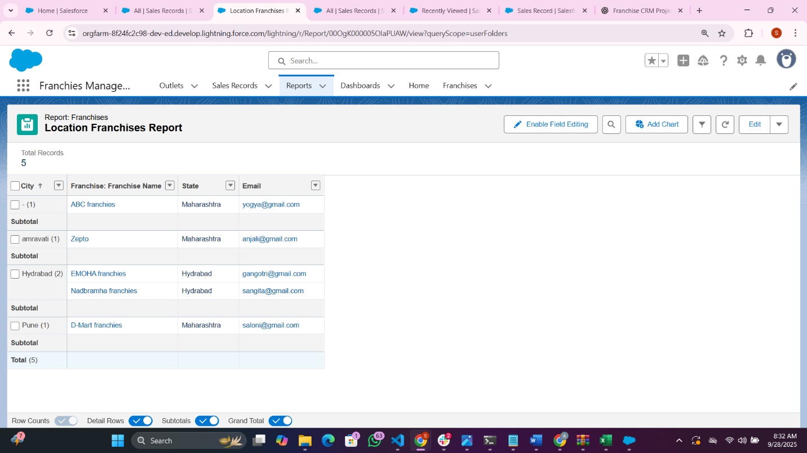

**2.Report Type**

1. Go to **App Launcher → Reports → New Report.**
2. Choose the required **Report Type** (e.g., Franchises with Outlets).
3. In the **Report Builder**, add filters, columns, and groupings as needed.
4. Click **Save & Run**.
5. In the Save dialog:
   * Enter **Report Name** (e.g., “Franchise Performance Report”).
   * Add a description if needed.
   * Click **Select Folder** → choose a **public/shared folder** (e.g., Franchise Reports).
   * Click **Save**.

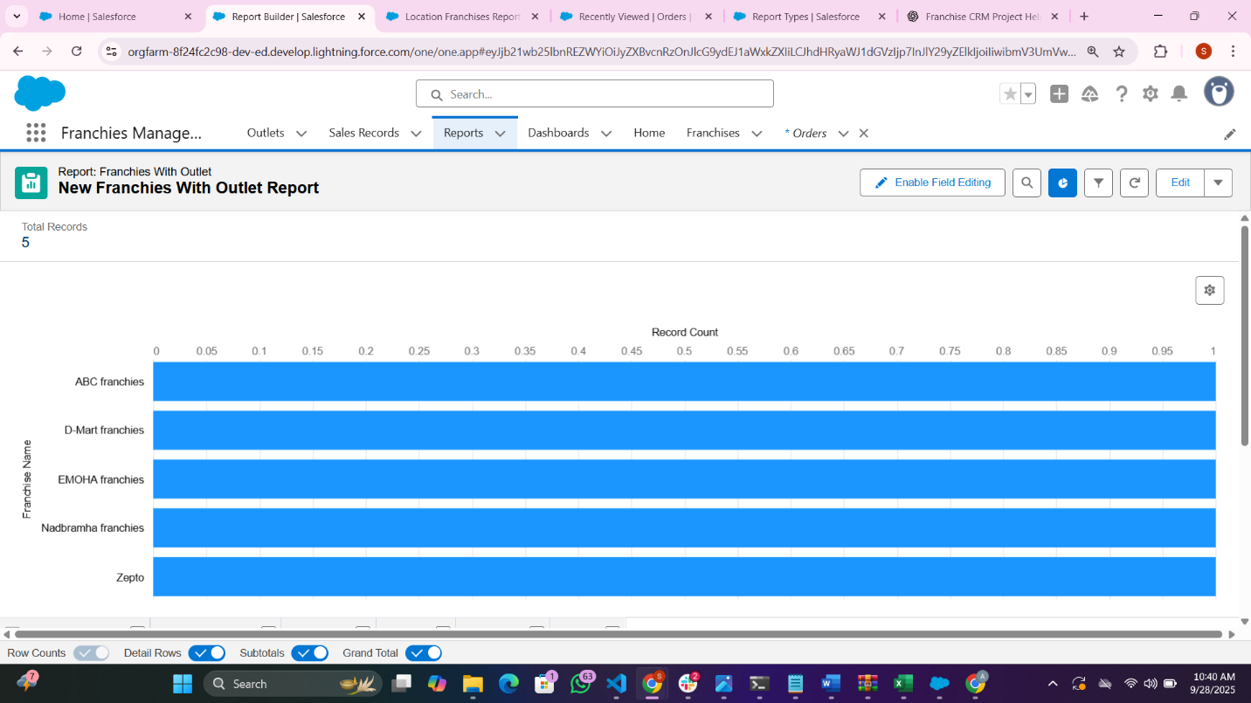

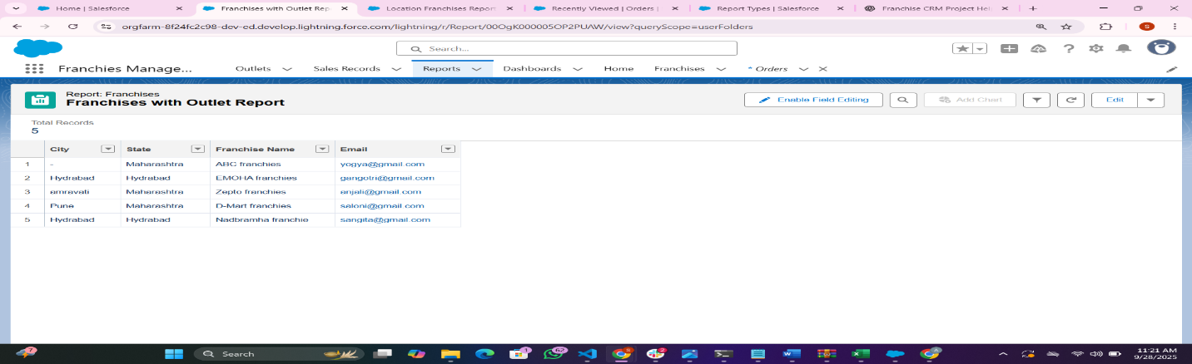

The reason we create and save the **report** (before making the dashboard) is:

* Dashboards in Salesforce **must be built on top of reports**.
* Each dashboard component (chart, graph, table, etc.) **pulls its data from a report.**
* By creating a report like “Franchises with Outlets” and saving it in a **shared folder** (e.g., Franchise Reports), other users and dashboards can access it.  
  👉 If you had saved it **in Private Reports**, no one else (and no dashboards) could use it.

So the use case is: **prepare, organize, and share structured data that dashboards can visualize**.

**Bottom of Form**

**3. Dashboards**

1 from app launcher select dashboards ---🡪 New dashboards

2 Dashboard Name : Franchiex Performance Dashboard in that I created bar chart and doubt chart

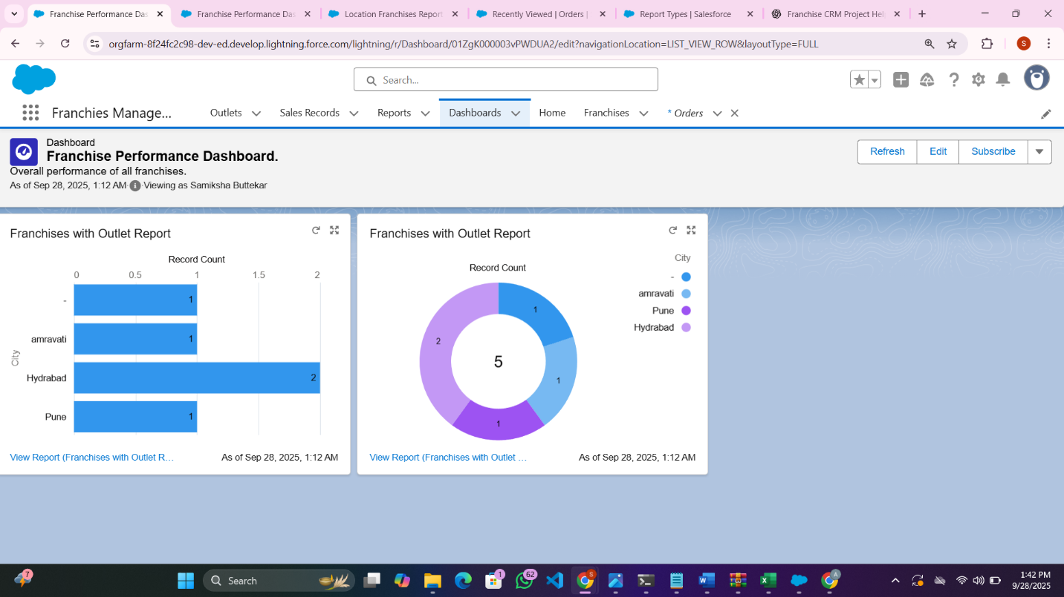

Use Case

In my Franchise CRM project, dashboards act like a **control center**. They take the reports we’ve built and turn them into easy-to-read charts and tables. For example:

* The bar chart shows how many outlets are in each city,
* The donut chart shows franchise distribution by state,
* And the table lists franchises with their managers.

This helps managers quickly track performance, identify gaps, and make better decisions without going through raw data. It basically saves time and gives a clear picture of how the business is doing.”

4.**Dynamic Dashboards (therotical for my project)**

### Is **Dynamic Dashboard** necessary for My project?

* **Yes →** If your project requires **different users (like Franchise Managers, Regional Managers)** to log in and see **only their own data** without you creating separate dashboards for each one.  
  Example: Manager A only sees Pune outlets, Manager B only sees Hyderabad outlets — but both use the same dashboard.
* **No →** If your project is more of a **demo/prototype** and **only Admins or one shared user** will use the dashboards.  
  In that case, a **static dashboard** (run as a specific user) is enough. All users will see the same numbers.

**6.Sharing Setting**

**In short, how we did it:**

* + Went to **Setup → Sharing Settings.**
  + Set **Org-Wide Defaults (OWD)** for each object:
  + e.g., Sales Record → Private (only owner can see)
  + Franchise → Public Read Only (everyone can see, only owner can edit)
  + Created **Public Groups** (e.g., “Franchise Managers”).
  + Added **Sharing Rules** to give access (e.g., all managers can view all sales).

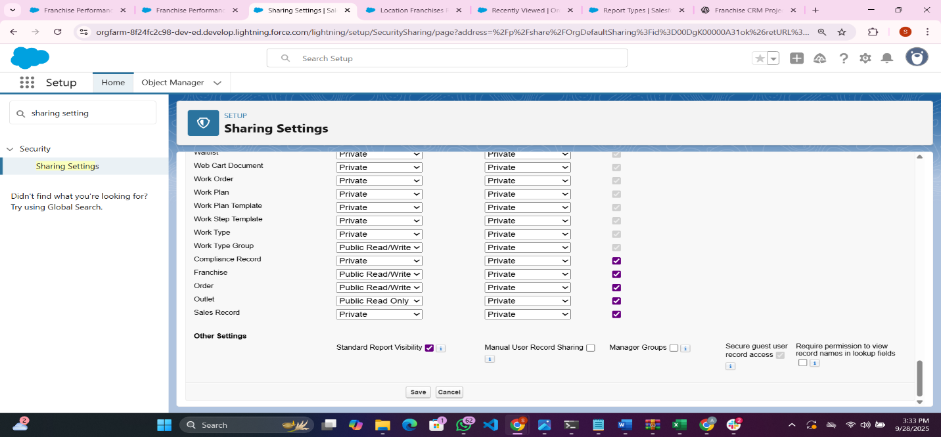

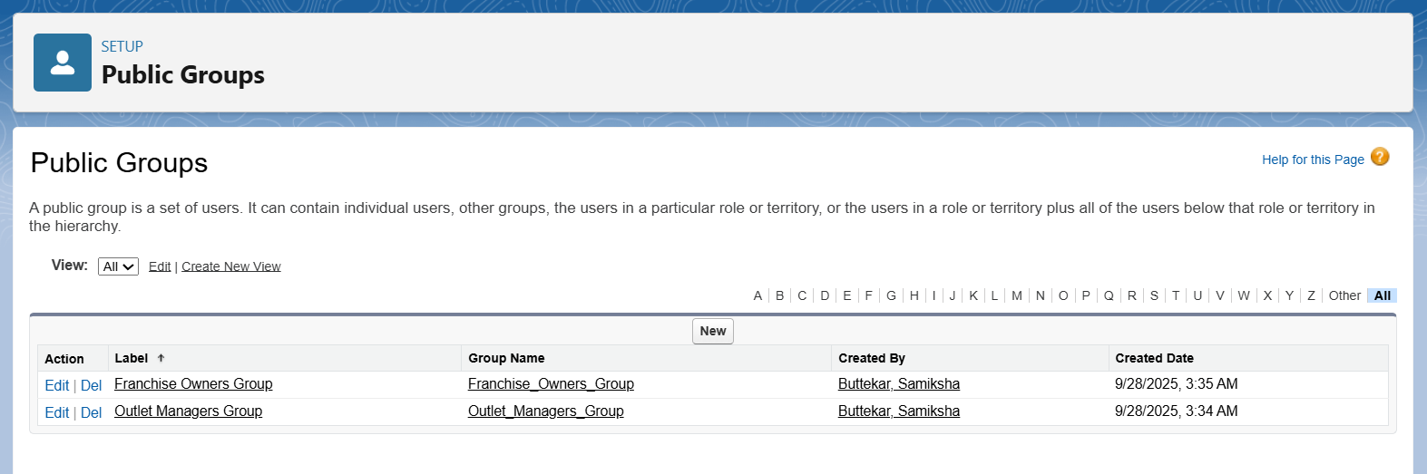

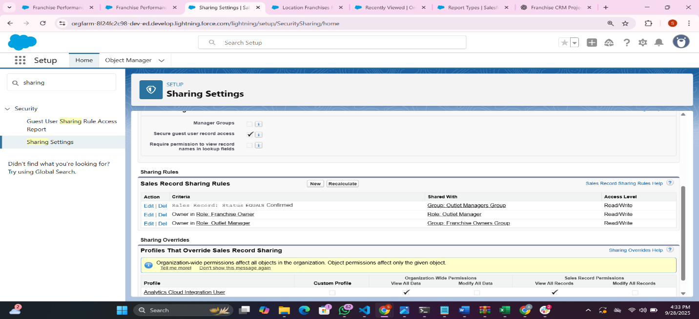

* Use Case of this step in my project

In your **Franchise Management CRM**, many users (like admins, managers, or franchise owners) will access records. This step — **Sharing Settings** — decides **“who can see what”** (e.g., which Sales Records, Franchise details, or Customer data each user is allowed to view or edit).

**6 Field-Level Security (FLS)**

Set FLS from Object Manager (per field)

1. Setup → **Object Manager** → open the object (e.g. **Sales_Record__c or Outlet__c).**
2. Left → **Fields & Relationships** → click the field (e.g. Amount__c).
3. Click **Set Field-Level Security**.
4. Tick **Visible** for profiles that should see the field; tick **Read-Only** if they should not edit.
5. Save.

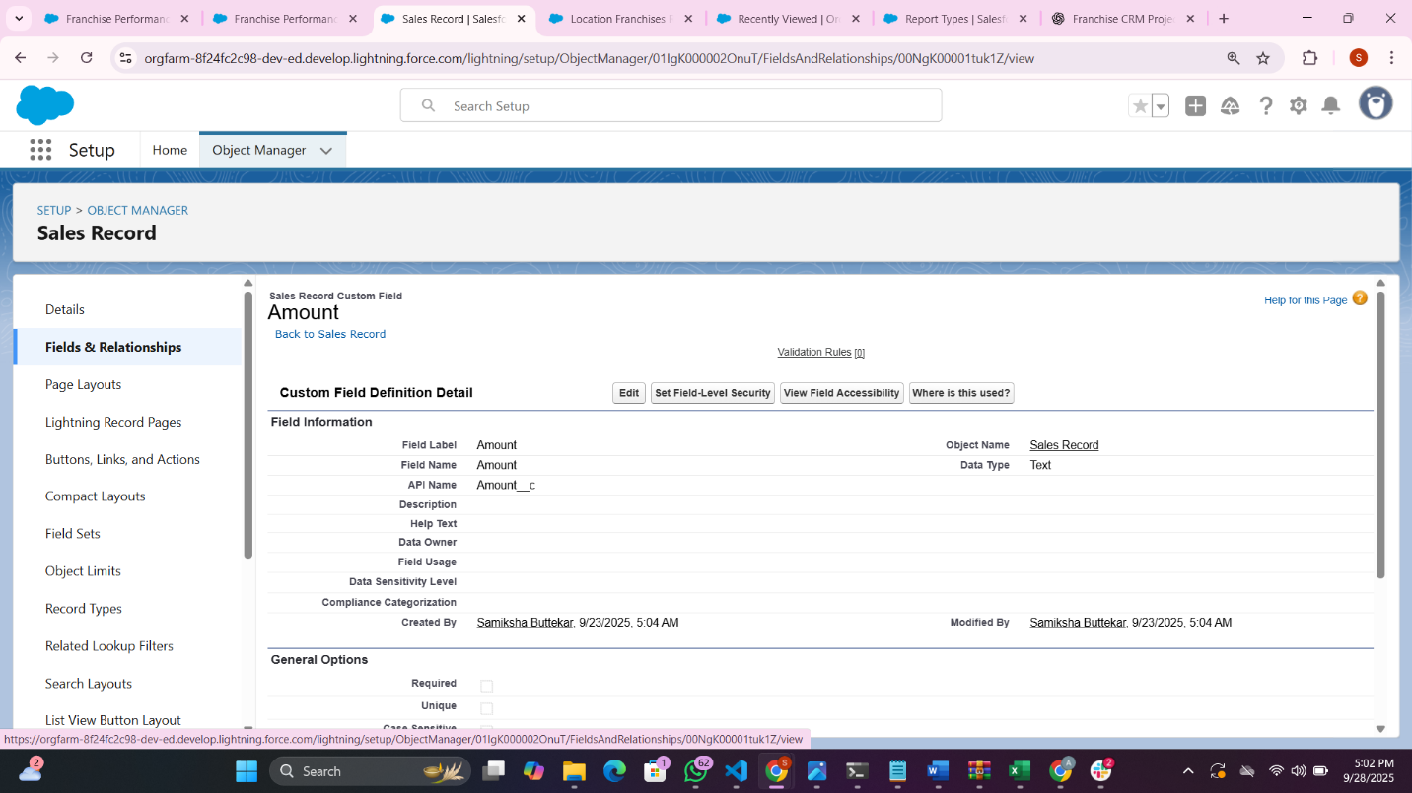

**7 Session Setting**

Session Setting get timeout in 30 minute

1. Setup → Quick Find → **Session Settings** → open.
2. Find **Session Timeout** (Idle session timeout).
3. Choose **30 minutes** from the dropdown.
4. (Optional) Check **Force logout on session timeout** if you want hard logout.
5. Save.

**Test:** Have a test user idle for shorter period than 30 minutes to verify still logged in; idle >30 mins to confirm timeout (or reduce to 5 mins for quick test then set back to 30).

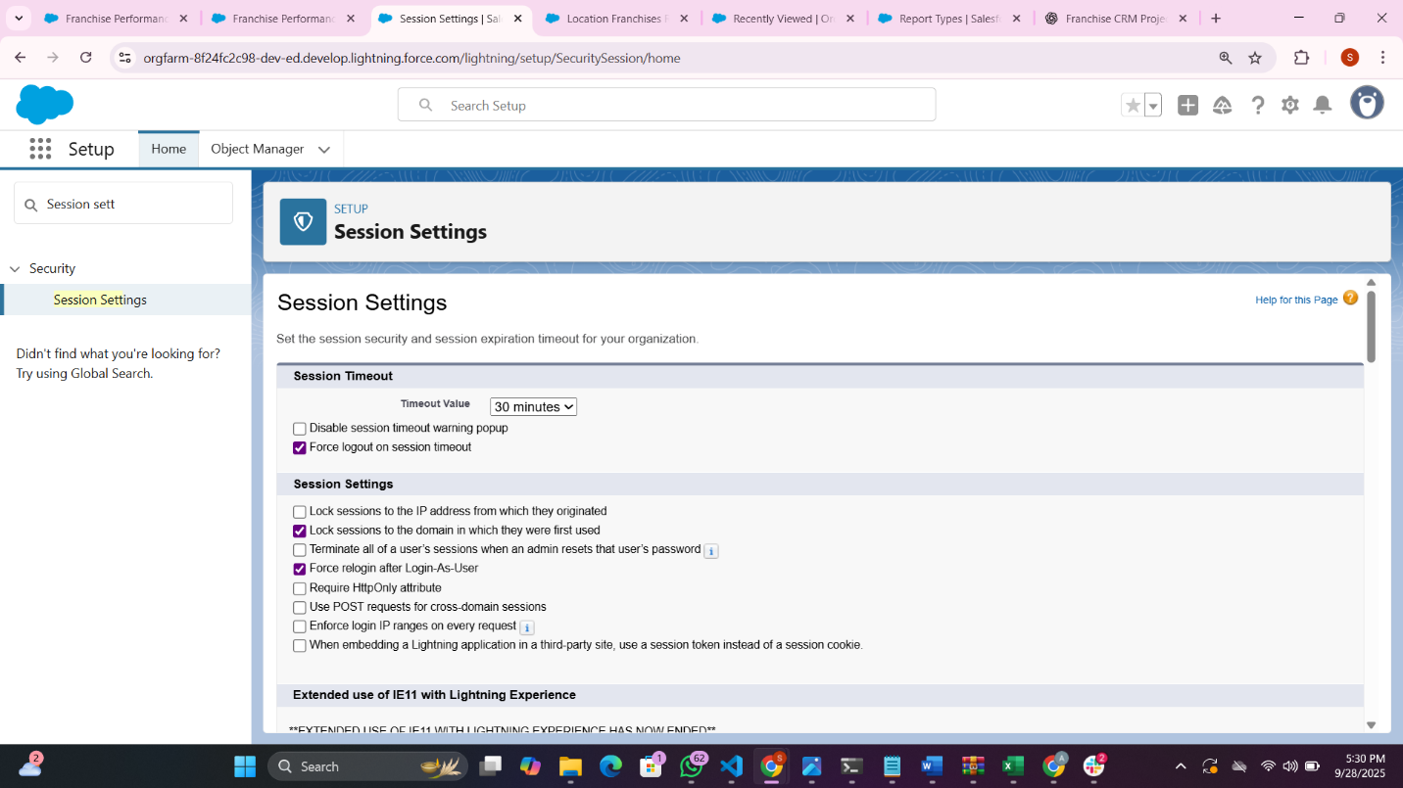

**8. Login IP Ranges**

* Setup → Quick Find → **Profiles** → open the profile to restrict (e.g., **Agent,** or **Outlet Manager** if needed).
* Scroll to **Login IP Ranges** → click **New.**
* Enter **Start IP Address** and **End IP Address** (for a single IP use same value).
* Example: 203.0.113.25 to 203.0.113.25
* Click **Save.**

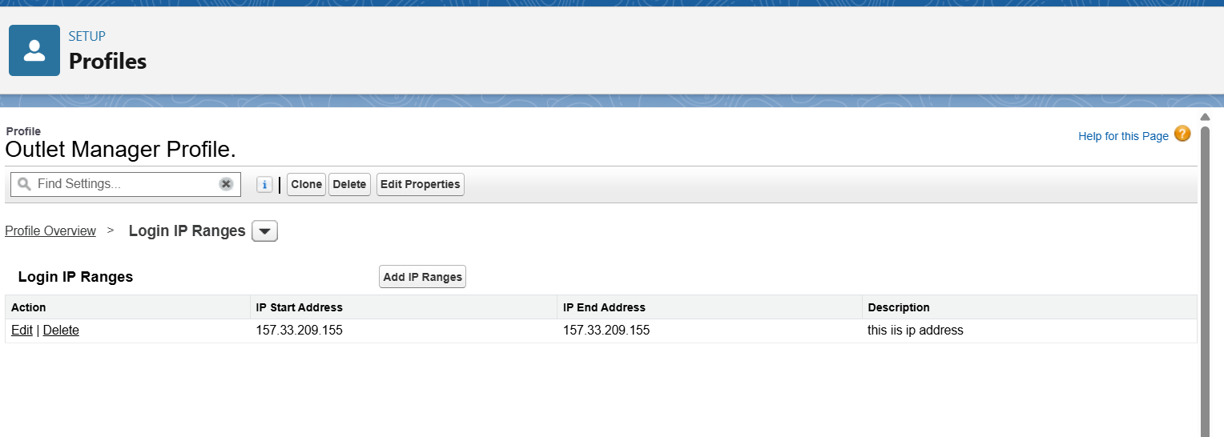

### Audit Trial

### View Setup Audit Trail (who changed setup)

1. Setup → Quick Find → **View Setup Audit Trail**.
2. It shows recent 20 changes; click **Download** to get last 6 months (CSV).
3. Save the CSV for your project evidence (who changed sharing, field settings,

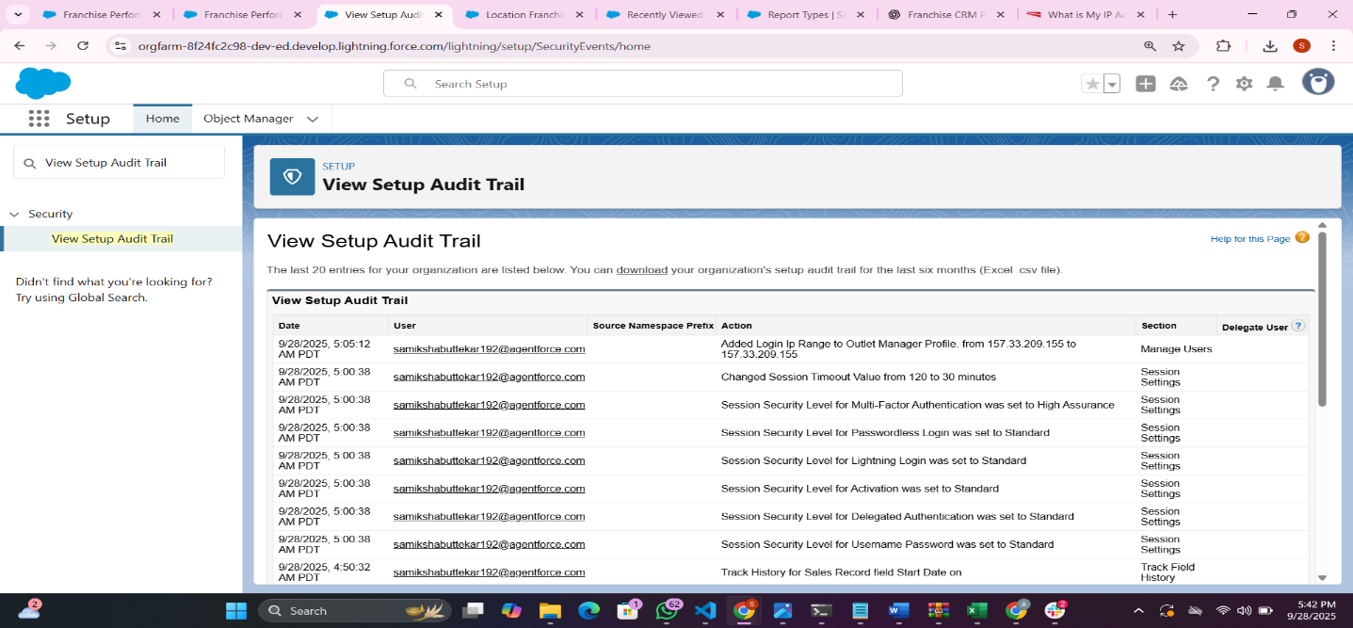

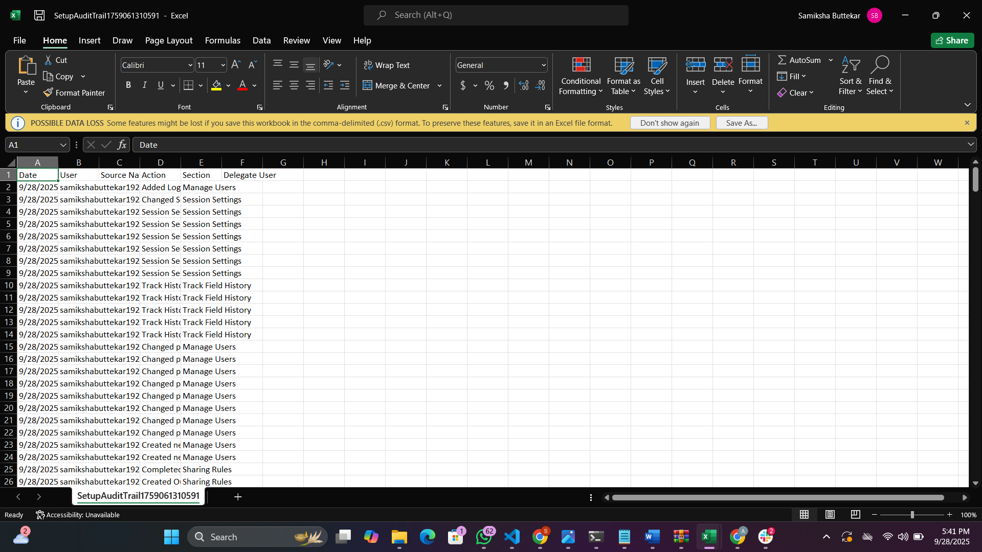

Phase 10: Final Presentation & Demo Day

**Goal: Wrap it up like a real project delivery.**

**This is my demo video link for franchise management CRM** [**https://drive.google.com/file/d/1pkoh1rGMVwup4yliBScnqIOXyamMK3qn/view?usp=sharing**](https://drive.google.com/file/d/1pkoh1rGMVwup4yliBScnqIOXyamMK3qn/view?usp=sharing)

**Thank You For Your Support Mam**